**Developing the System**

Now that I’ve finished designing my database, I have developed a file from my improved design, as well as ensuring that appropriate referential integrity constraints are considered. That includes primary and foreign keys as well as validation check constraints and relevant ‘Lookups’.

**Student Table:**

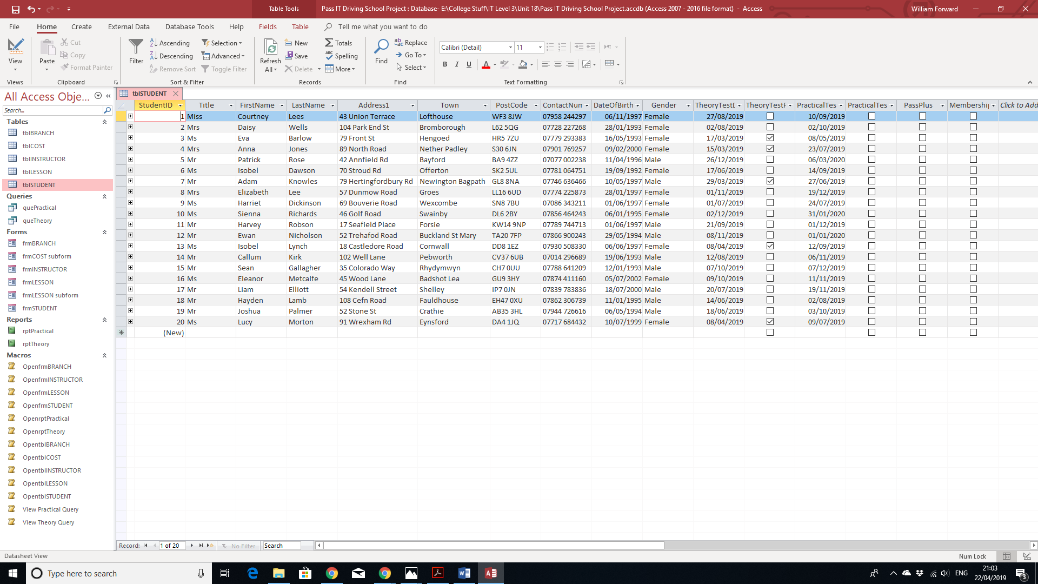

**Instructor Table:**

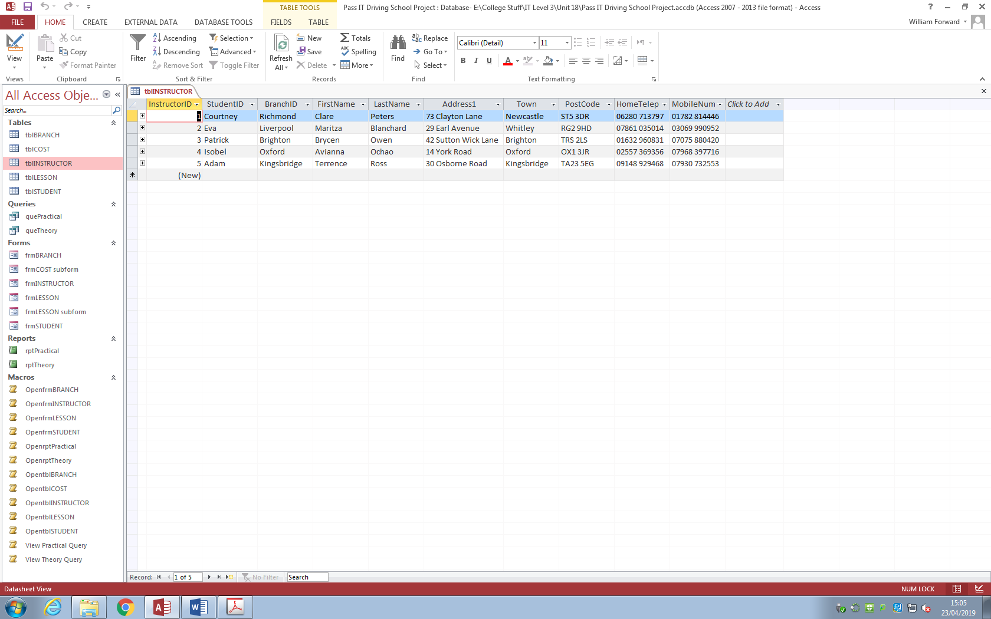

**Lessons Table:**

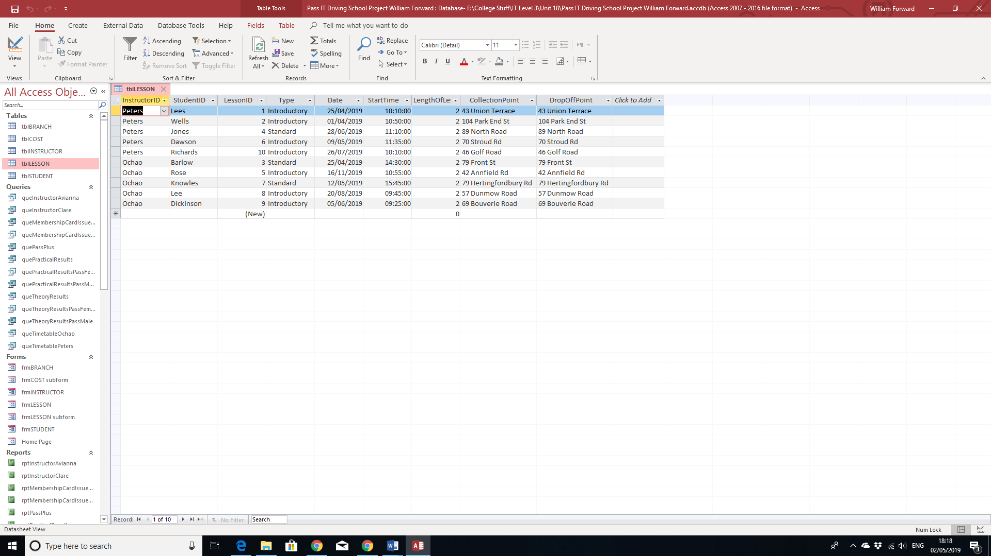

**Branch Table:**

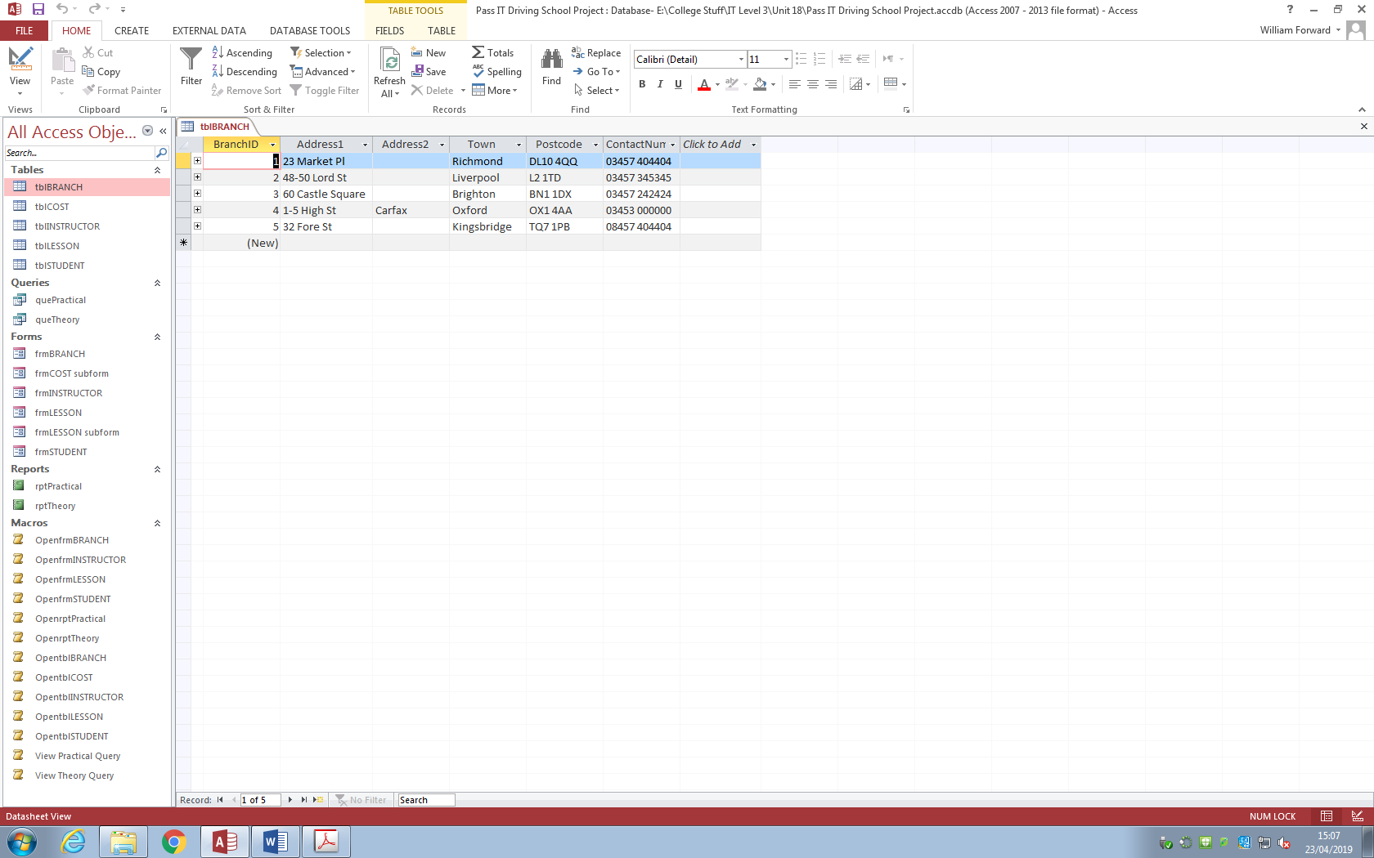

**Relationships:**

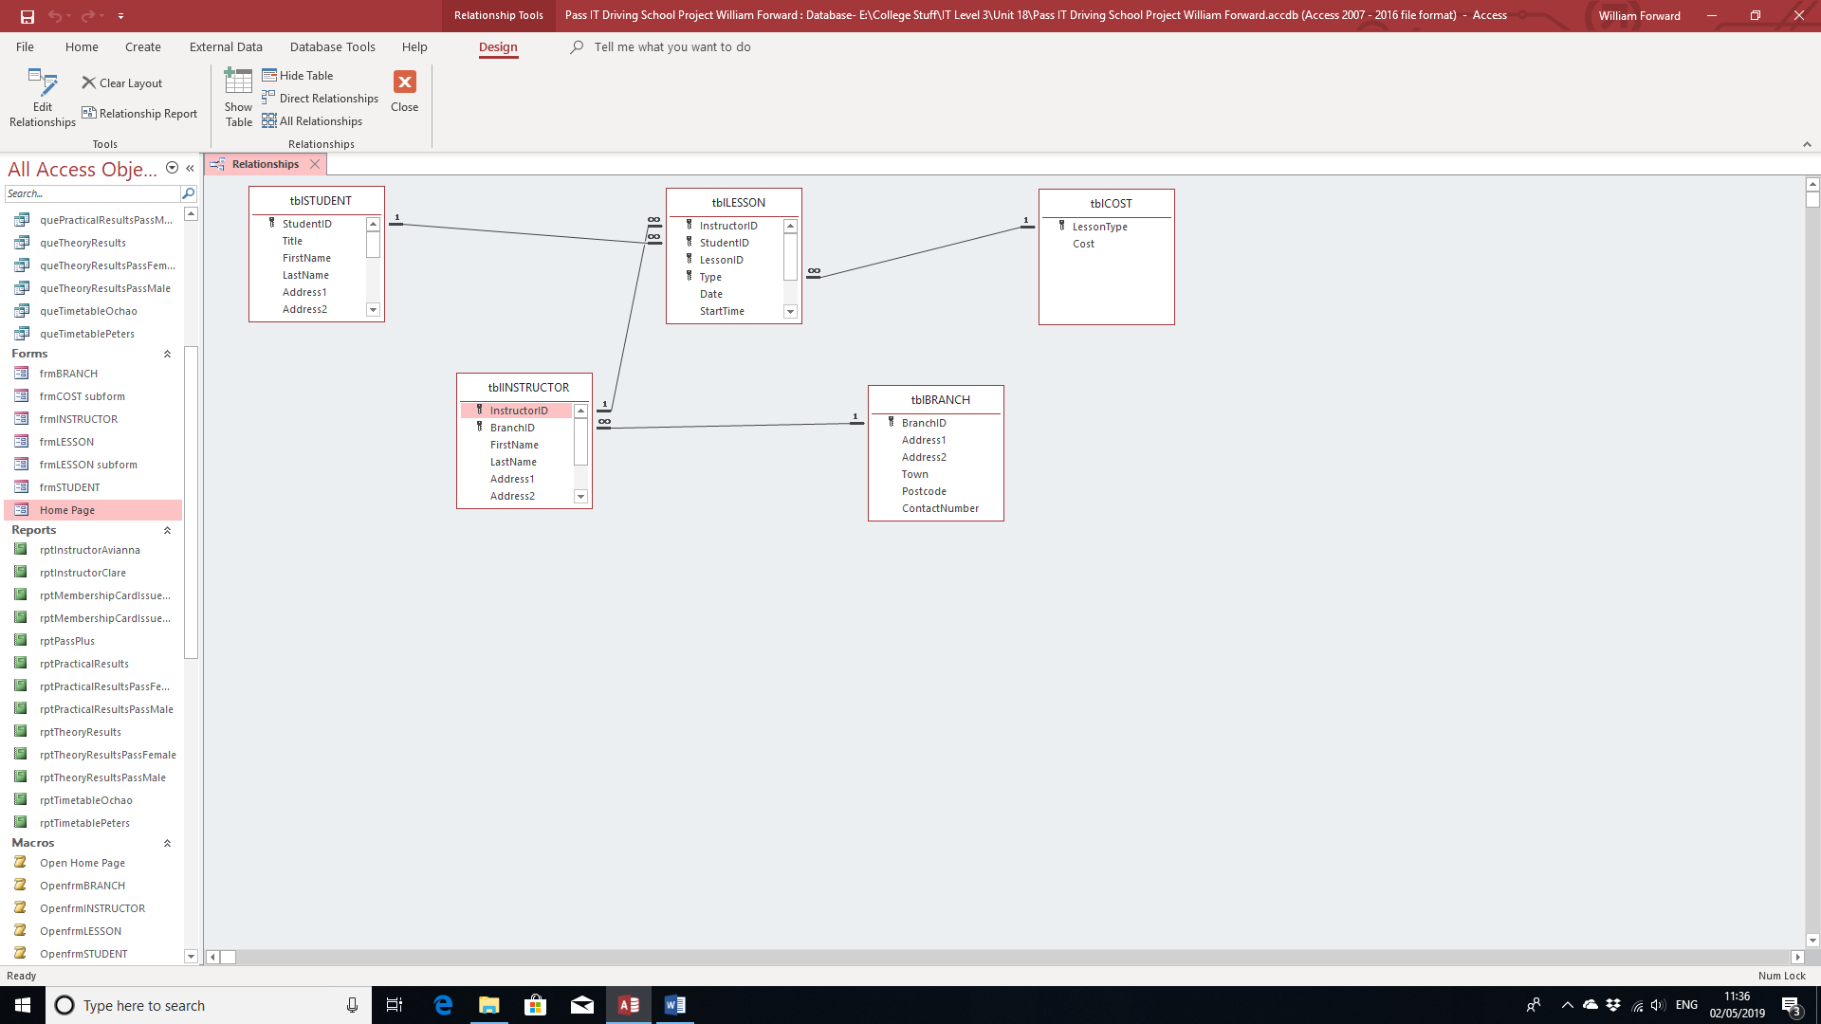

**Referential Integrity:**

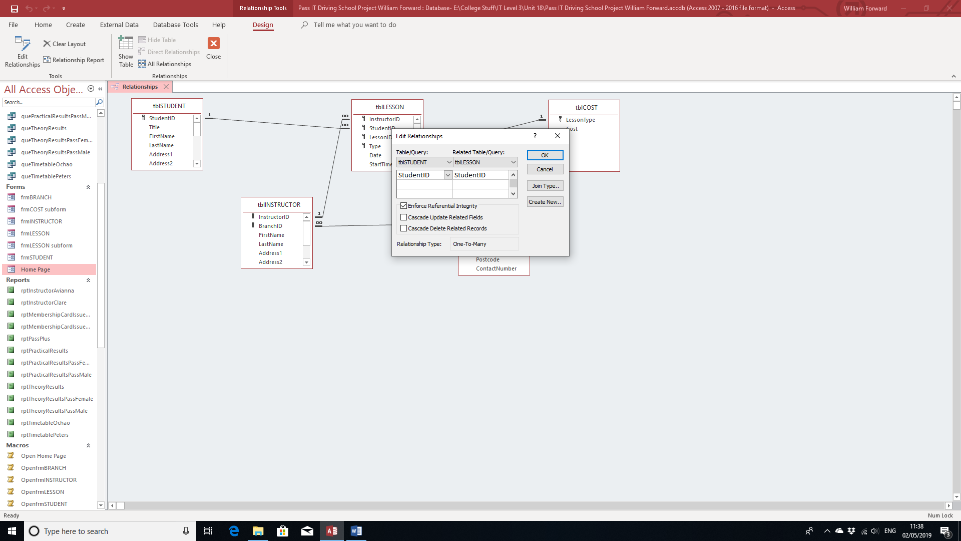

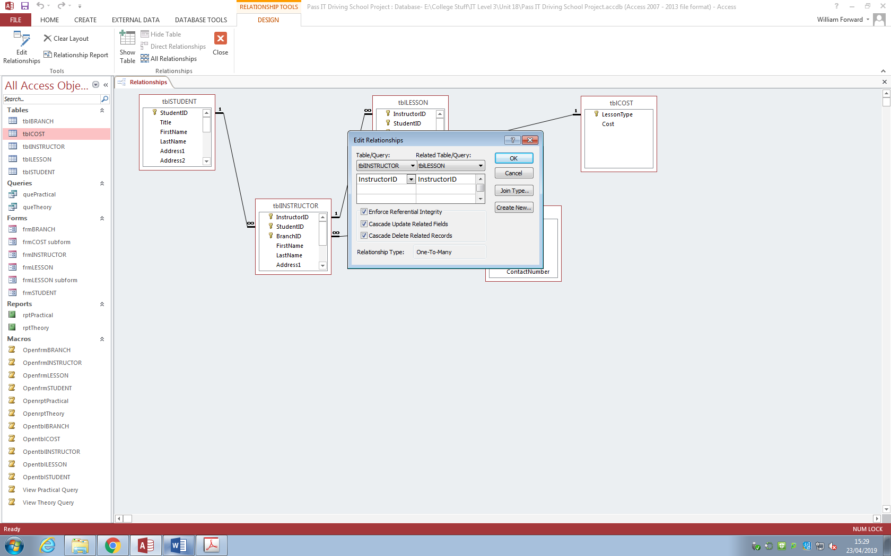

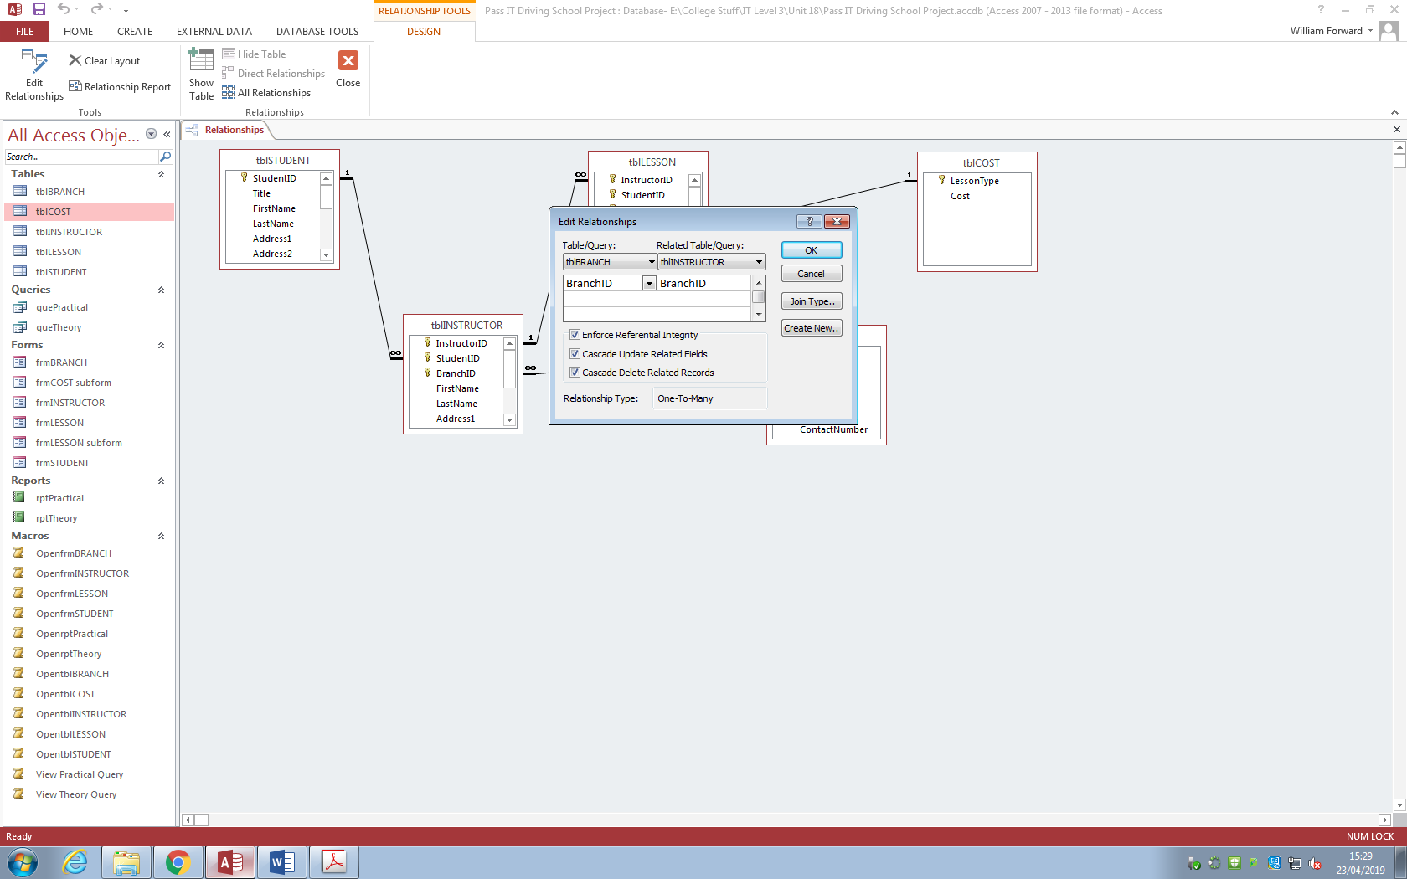

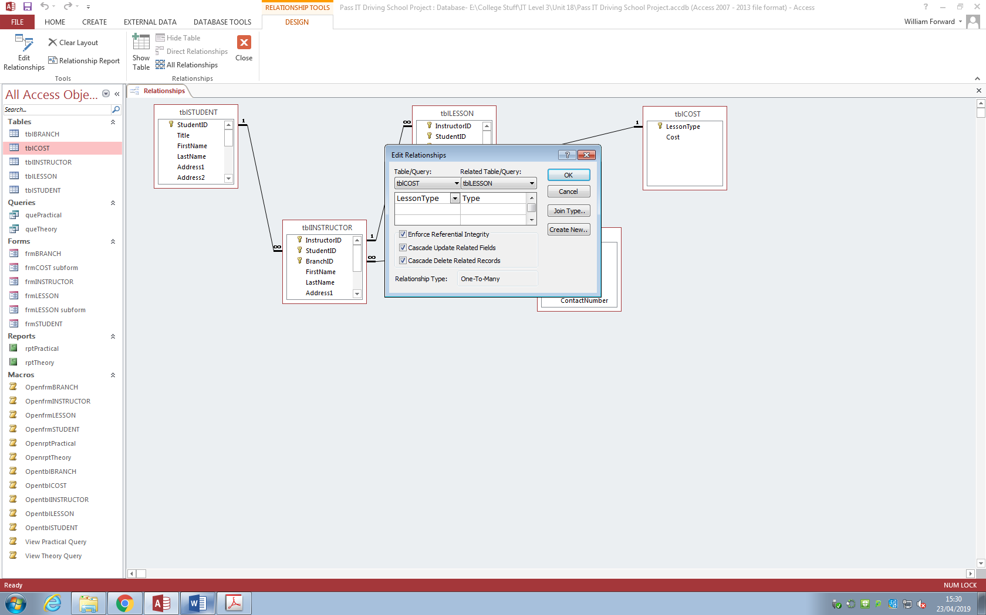

In Addition, I have also imported data from another source that included 10 more students for the student table.

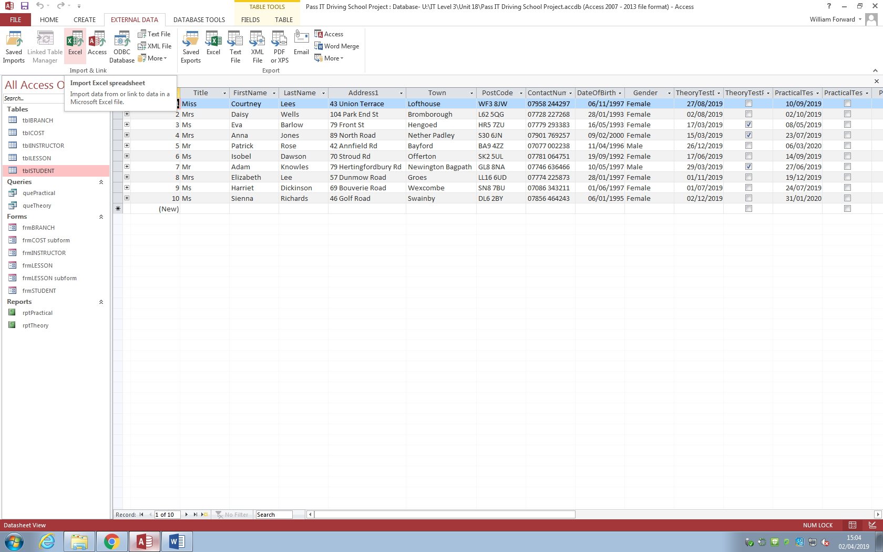

Firstly, I went to “External Data” at the top of the menu and clicked on “Excel” above “Import & Link”.

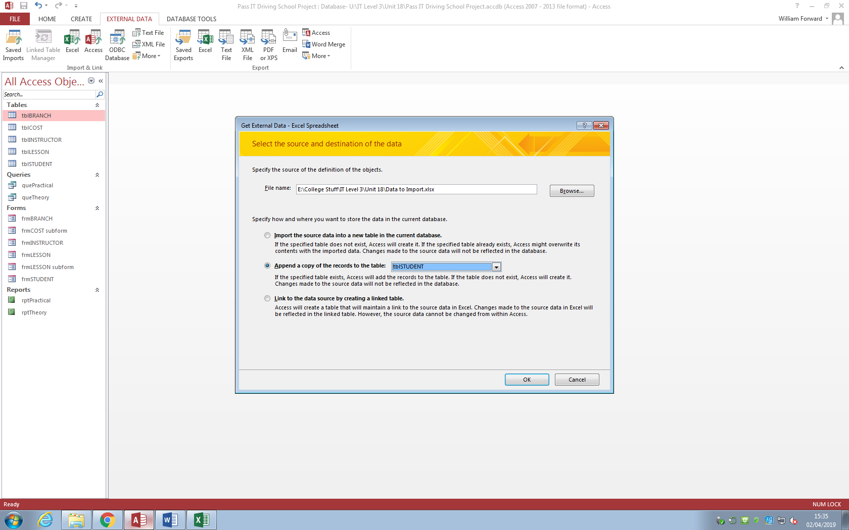

Once this page appears, I browsed the location of the file, then selected “Append a copy of the records to the table: tblSTUDENT” to export the data onto that table.

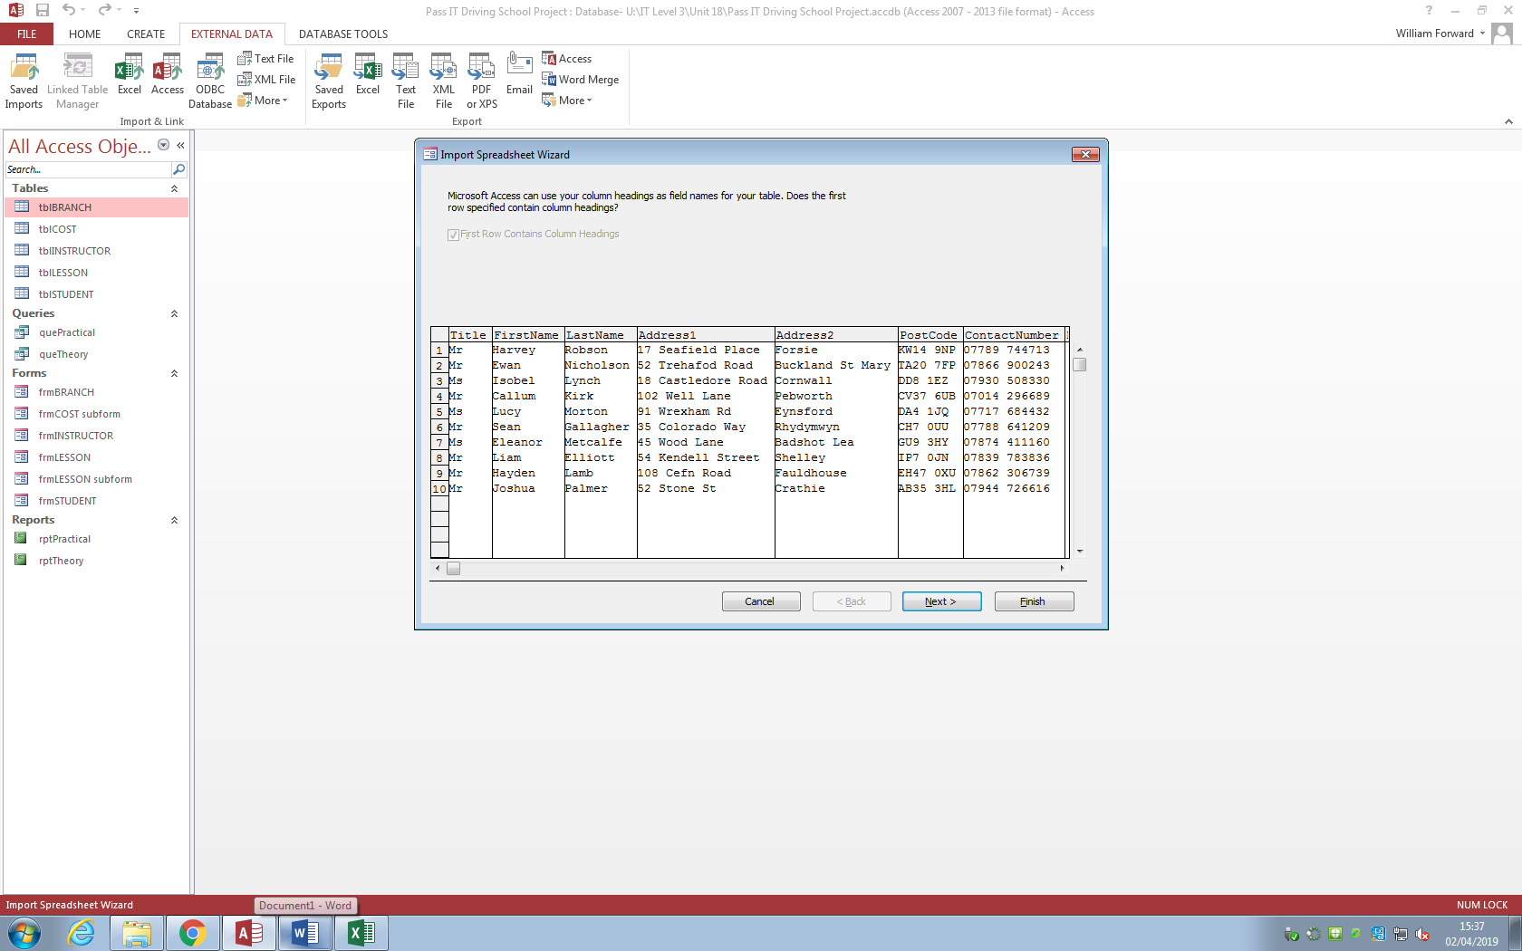

As everything seems fine here, I clicked “Next”.

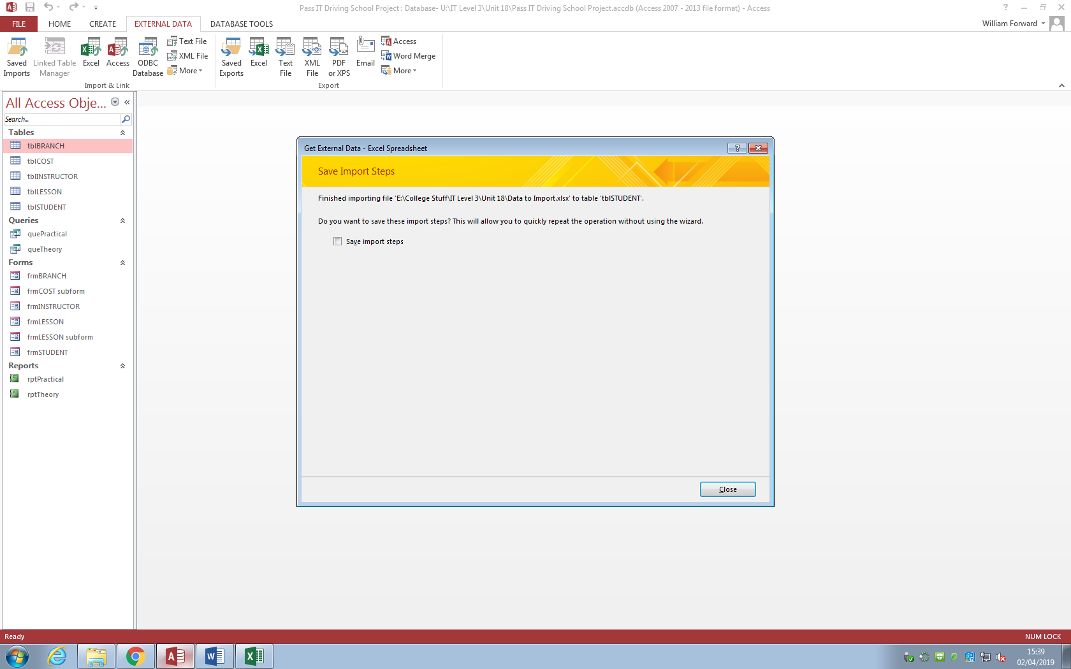

After that, I clicked “Close”.

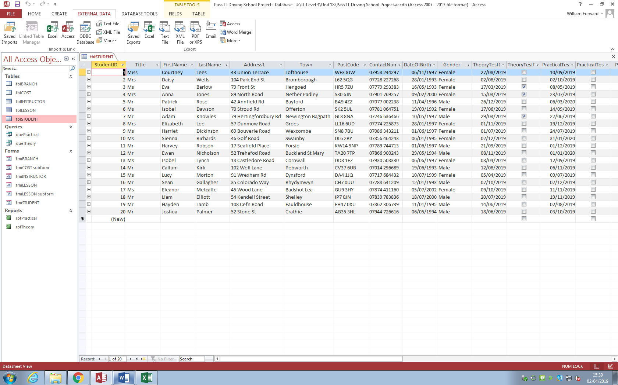

Here is the student table with the 10 added students.

**Note:** There was one bit of data that was outdated. This was while I was working on the database on another computer on a date after the one set on the data, causing it to be outdated. I did manage to create the same one of that same student, just with a different, more current date.

Here below is the current version:

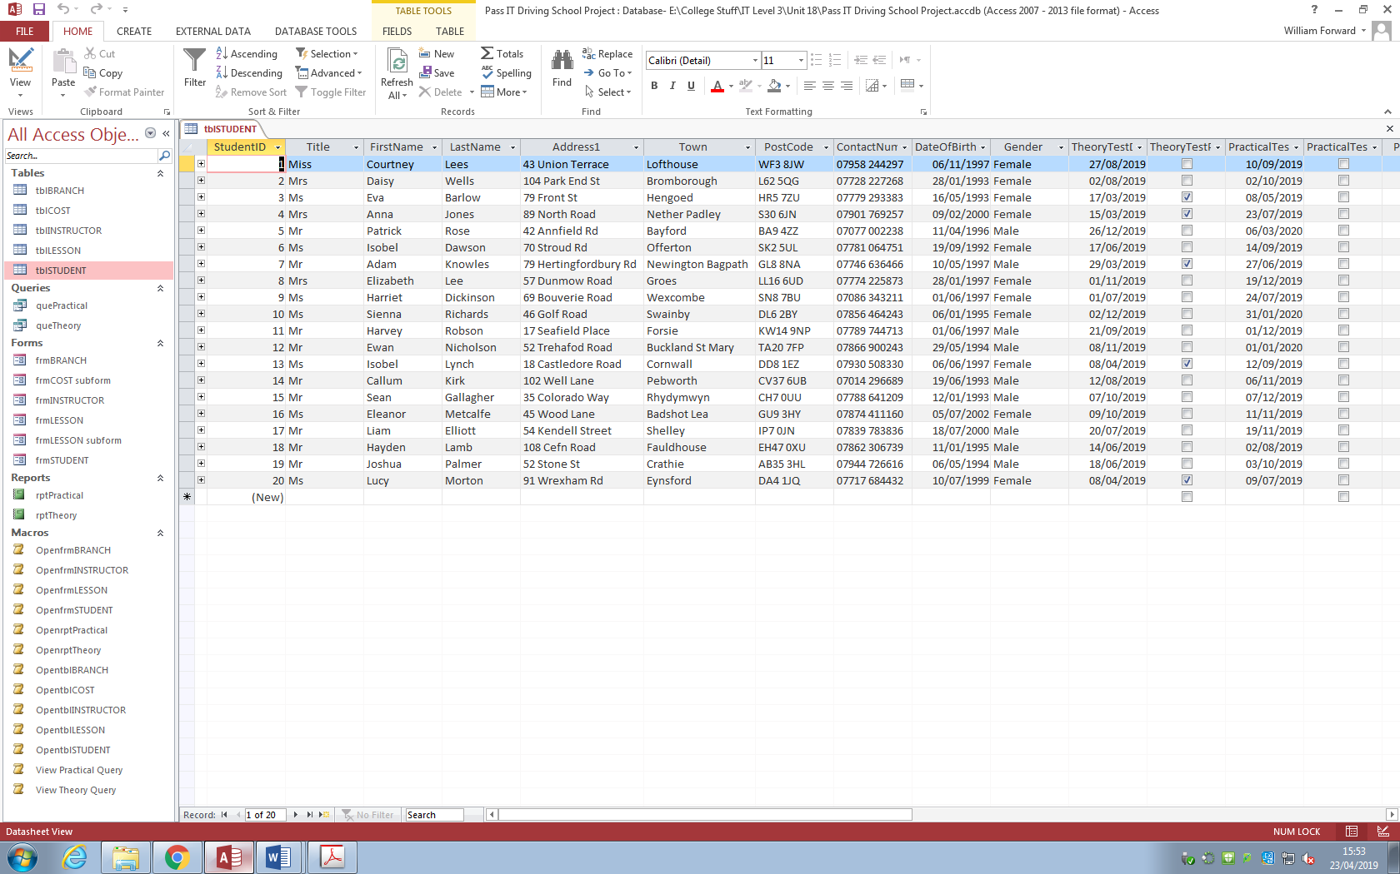

Here are the forms I have designed for the tables, which are used to enter new records. Except for the Home Page:

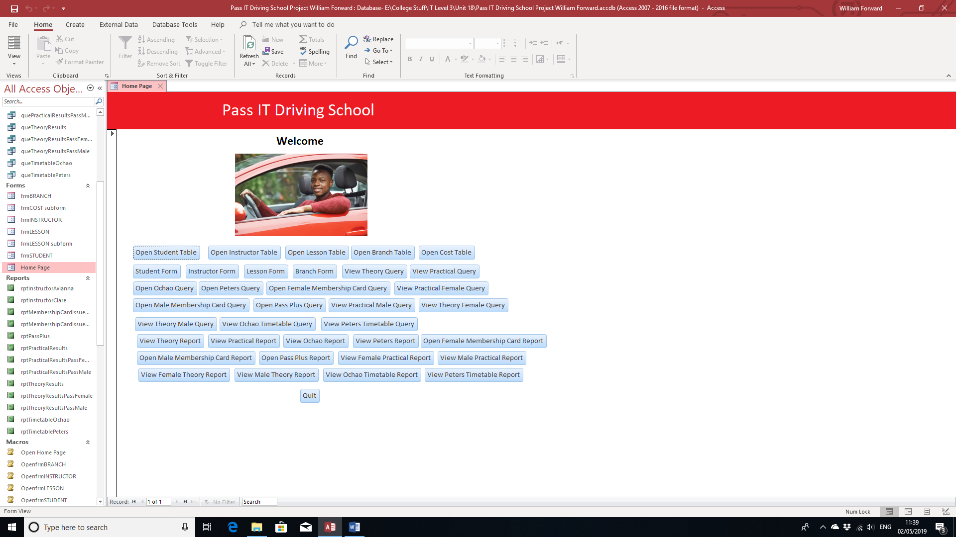

Student Form:

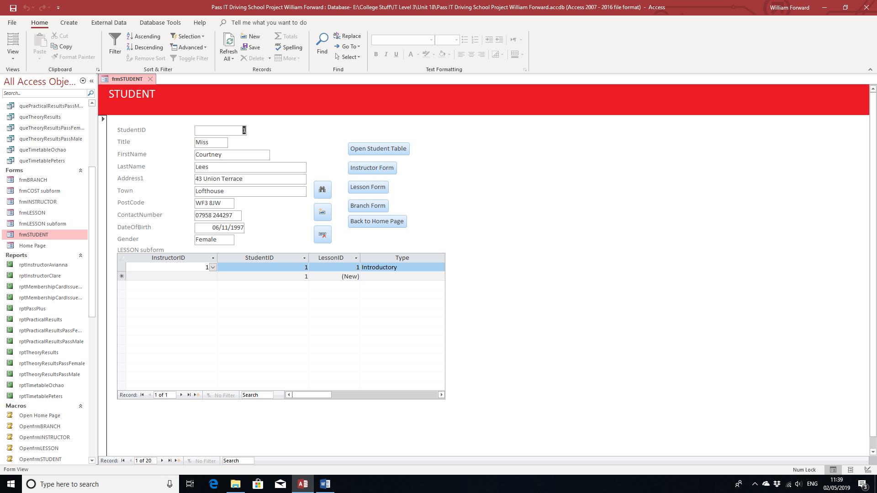

Instructor Form:

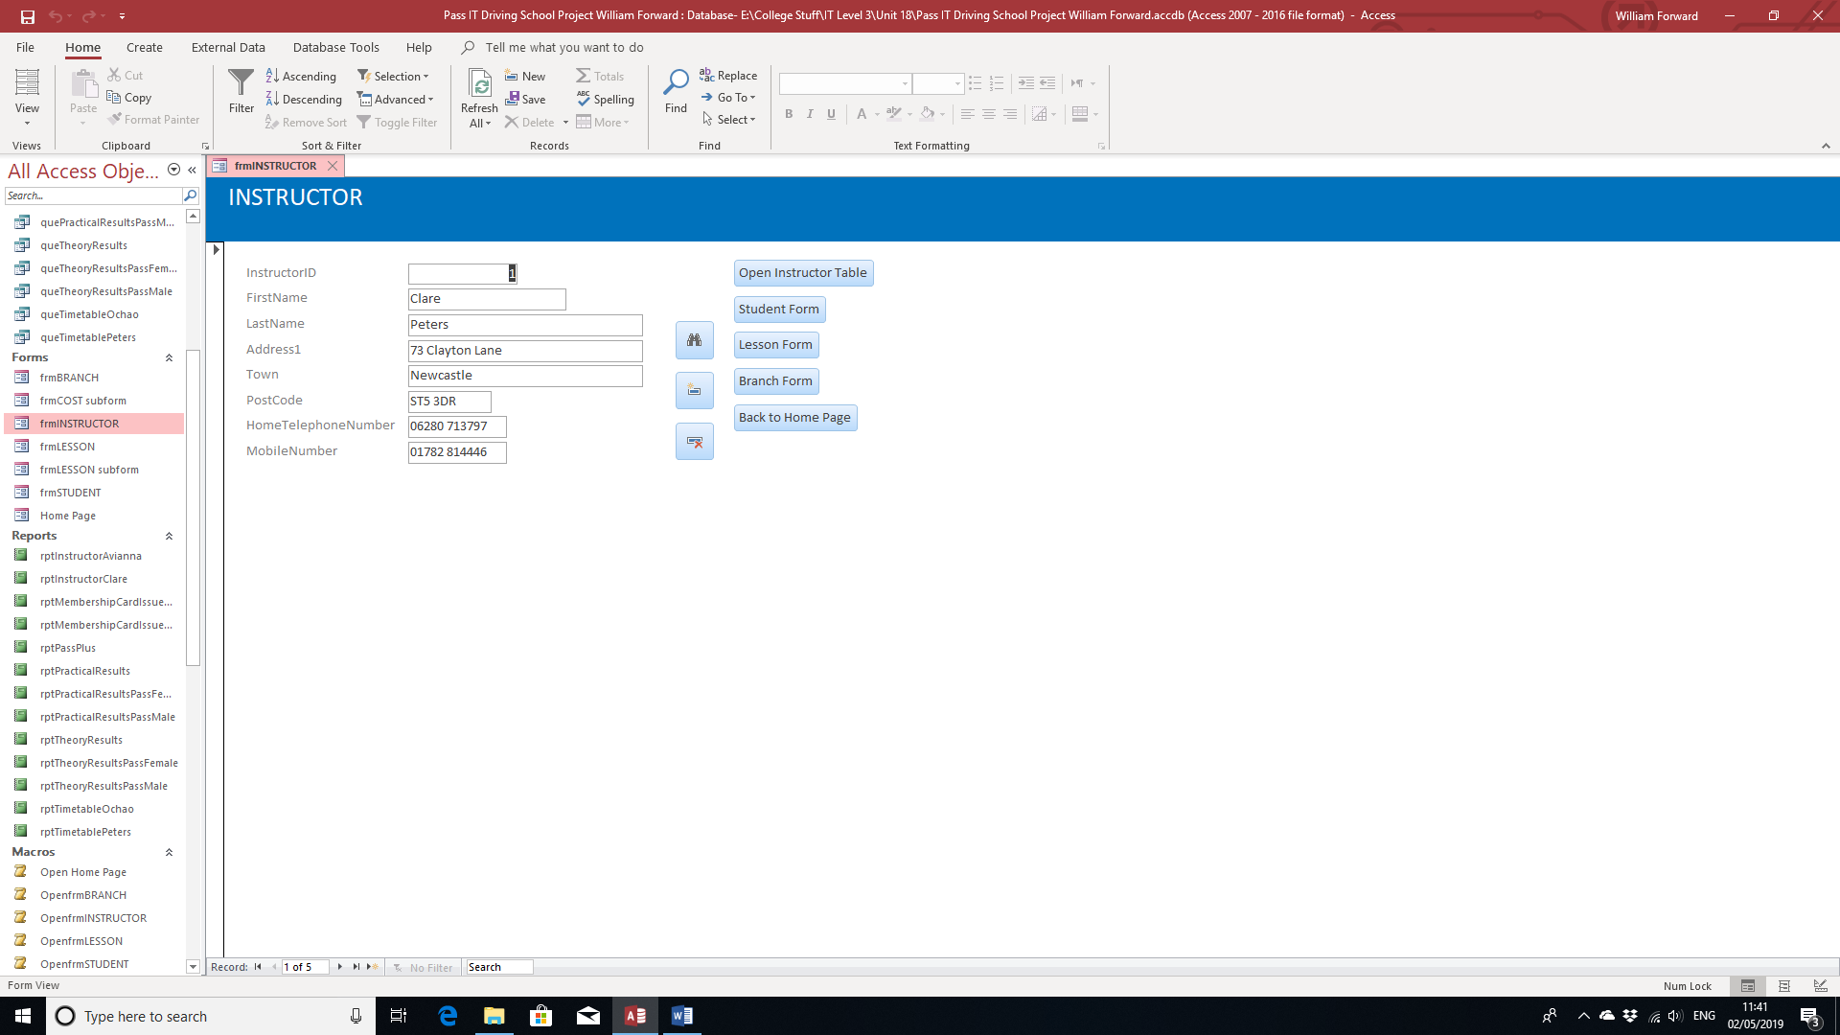

Lesson Form:

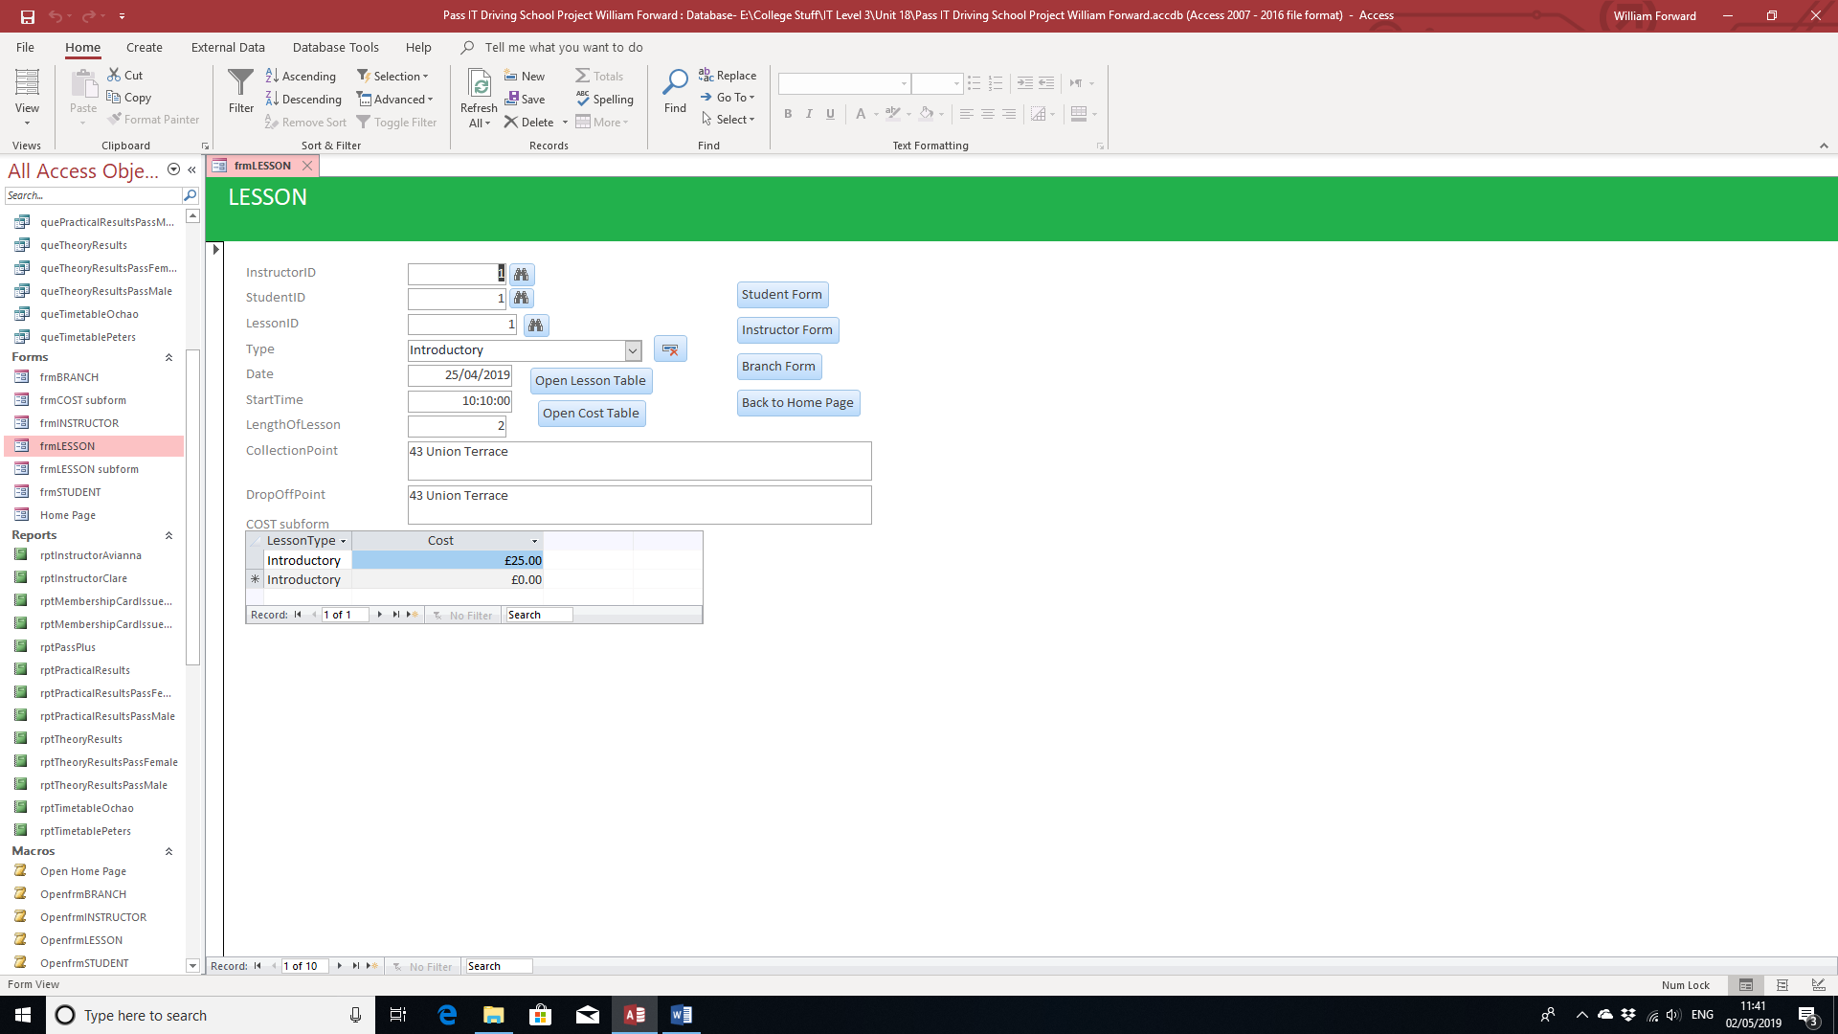

Branch Form:

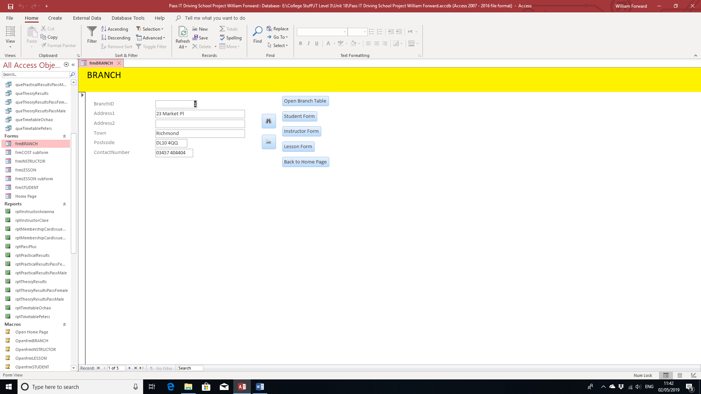

I have also set up 3 strategies to ensure both the validation and integrity of data:

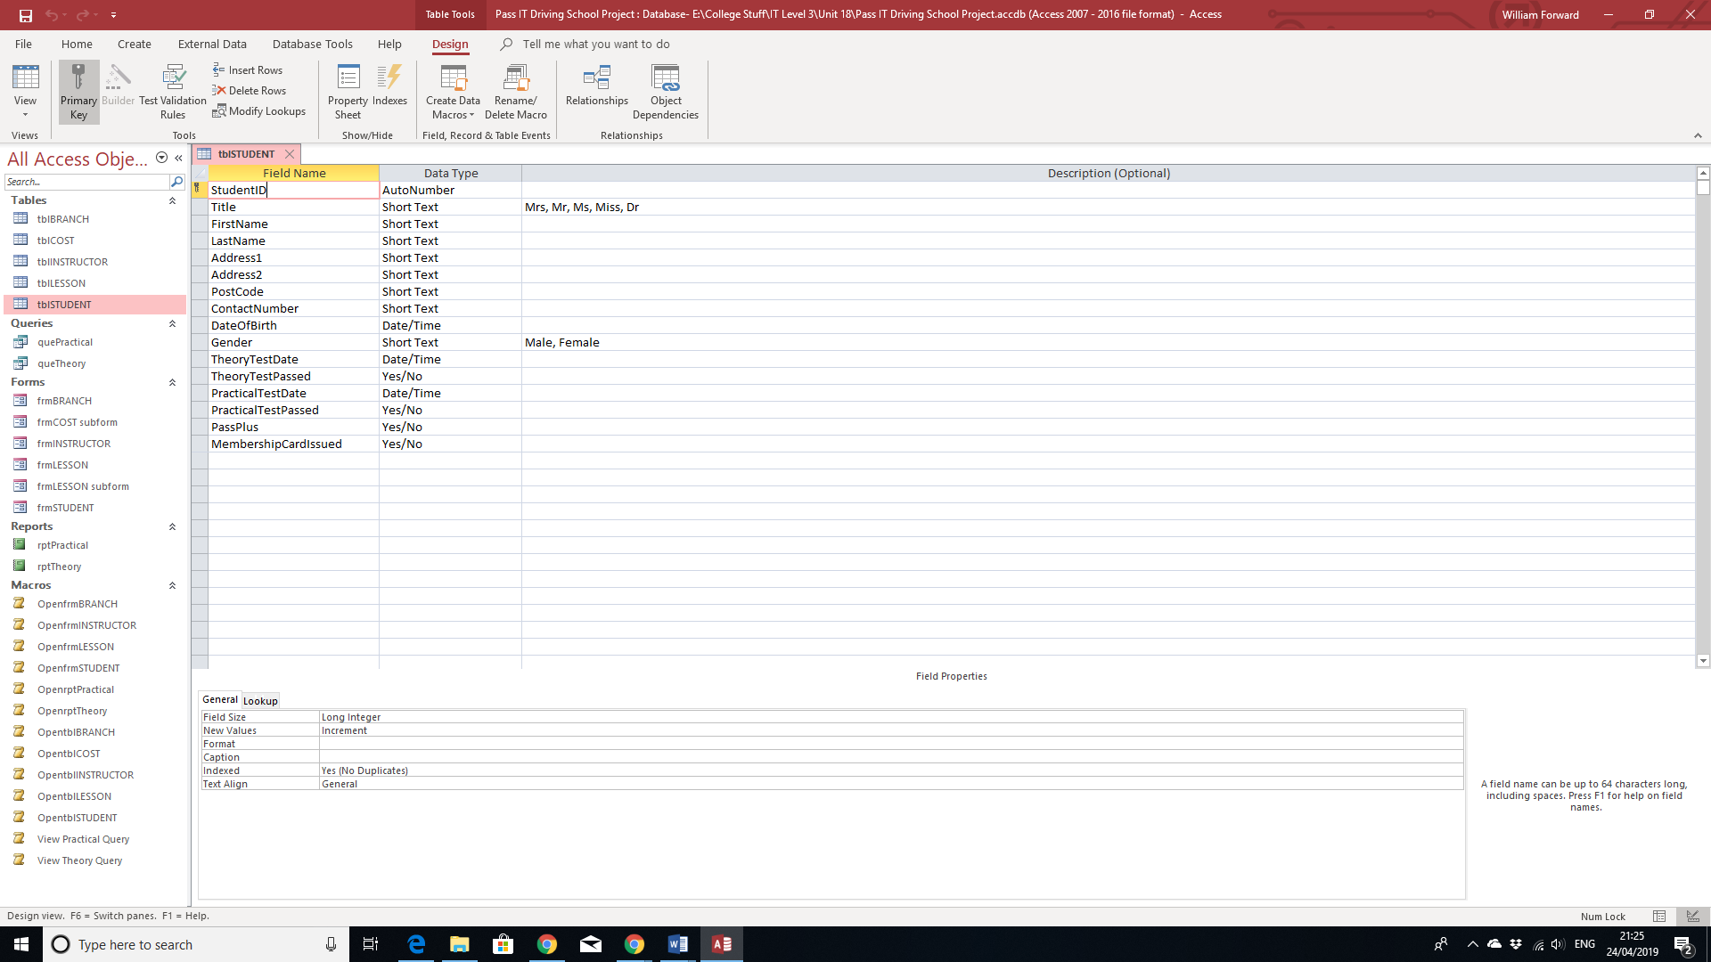

The first strategy is that the data has been indexed to not allow any duplicates. This applies to the ID numbers for the data in the table.

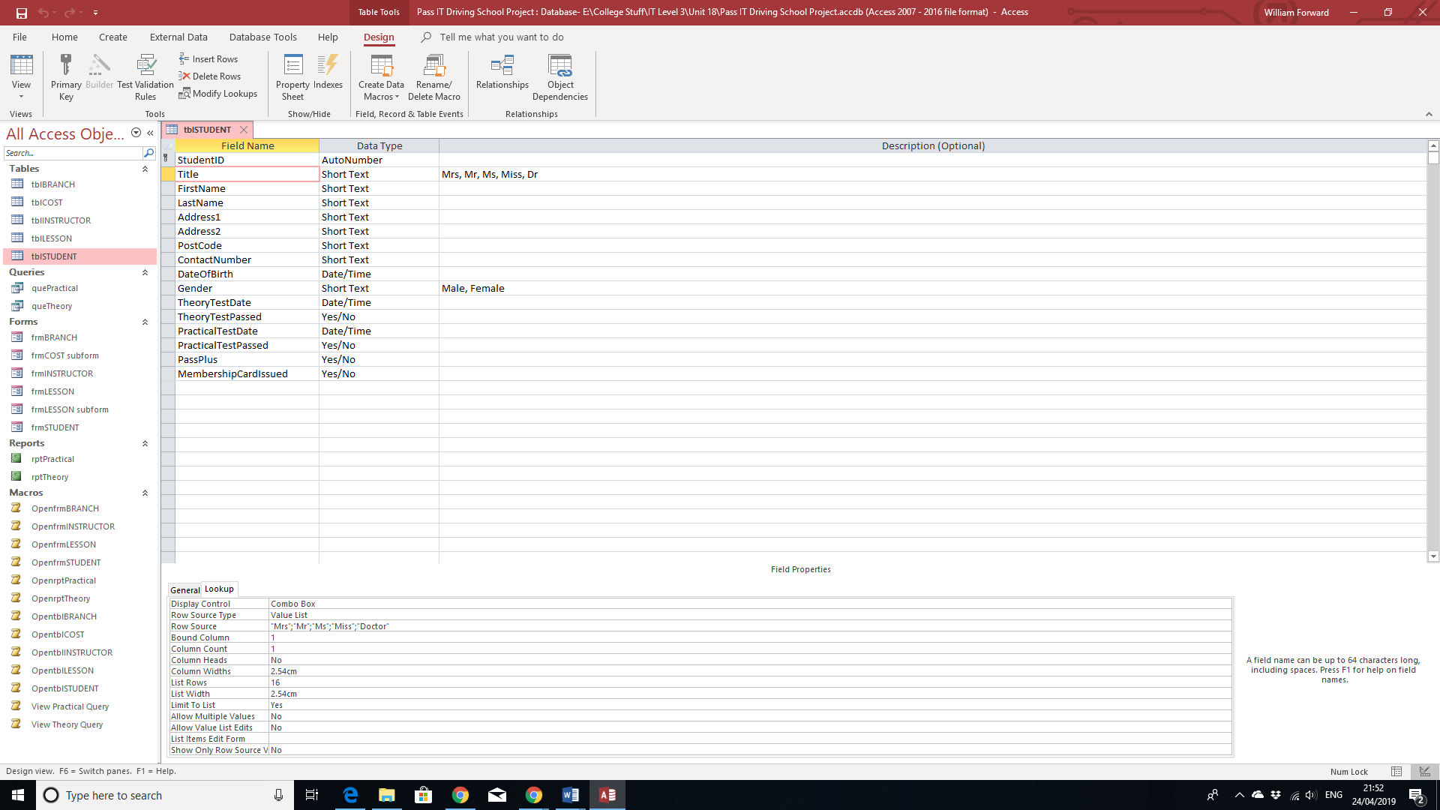

The second strategy is the combo box. This means that only the values in the combo box, as shown in the row source can only be chosen.

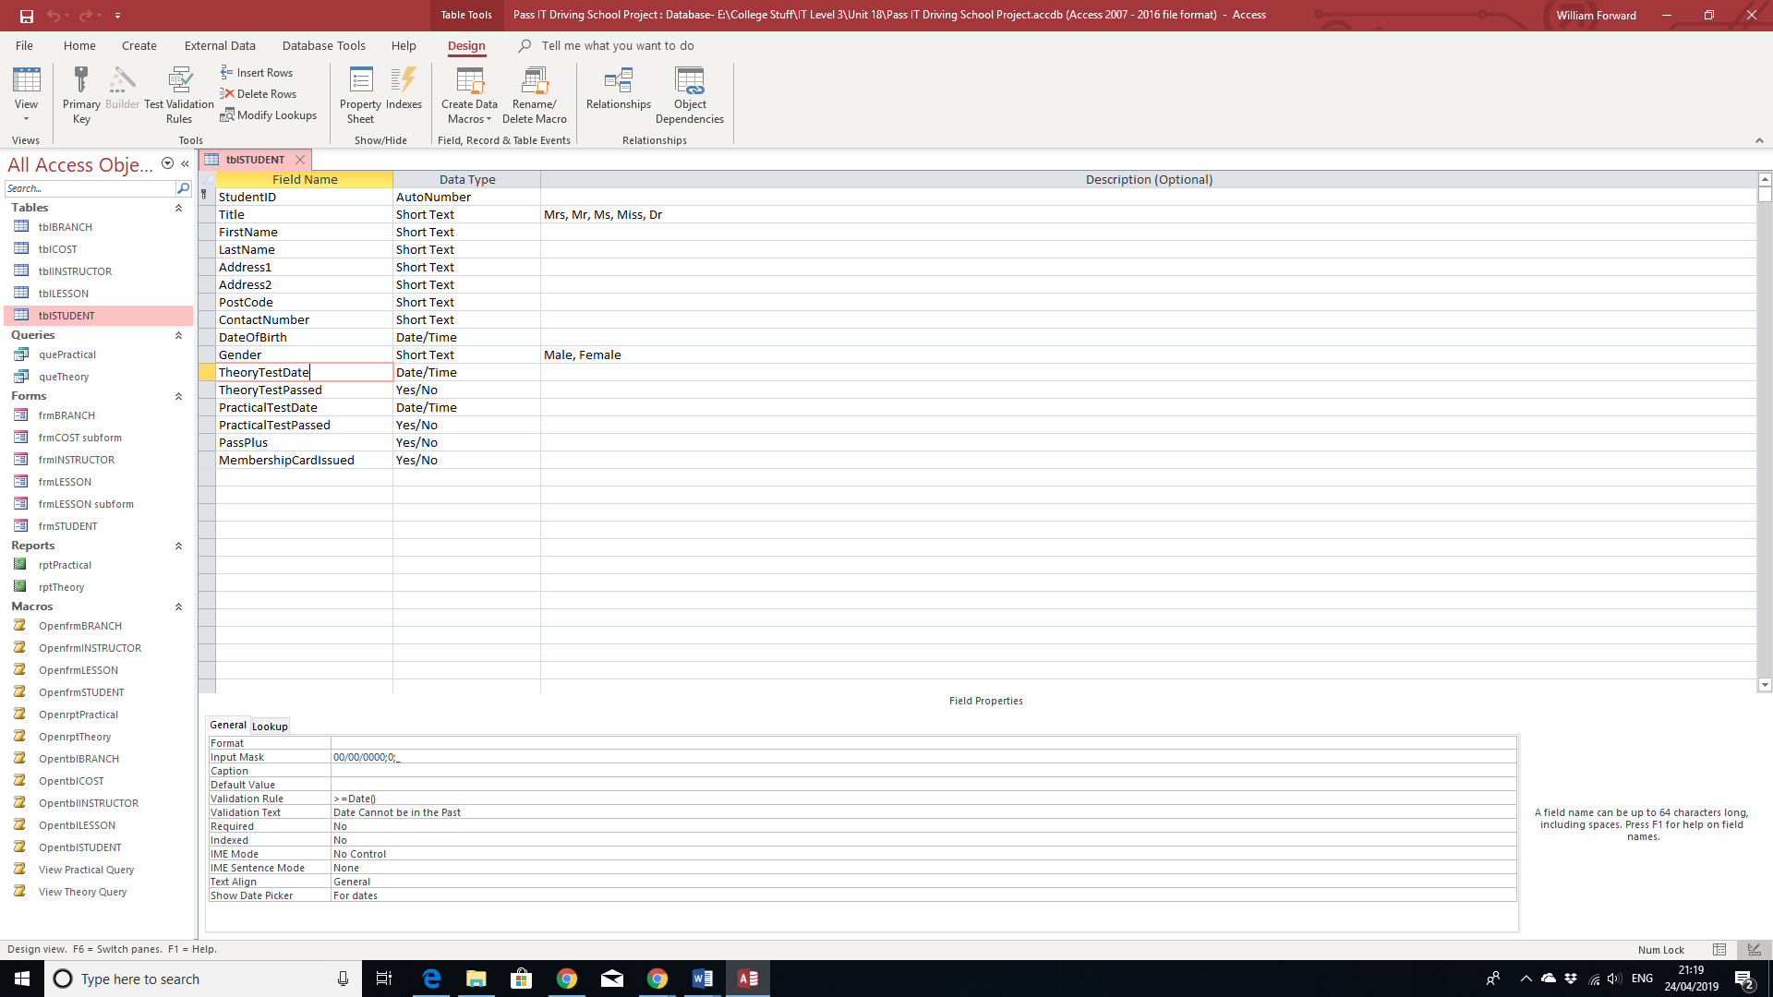

The third strategy is both the validation rule and text. These are set up so that the data can be more accurate. For example, the validation rule above has been applied so that the date of the theory test or practical test in set in the future rather than the past depending on the date it was booked.

I have also set up multiple queries, each from less than 2-3 tables with 2 different categories.

Theory Test Query:

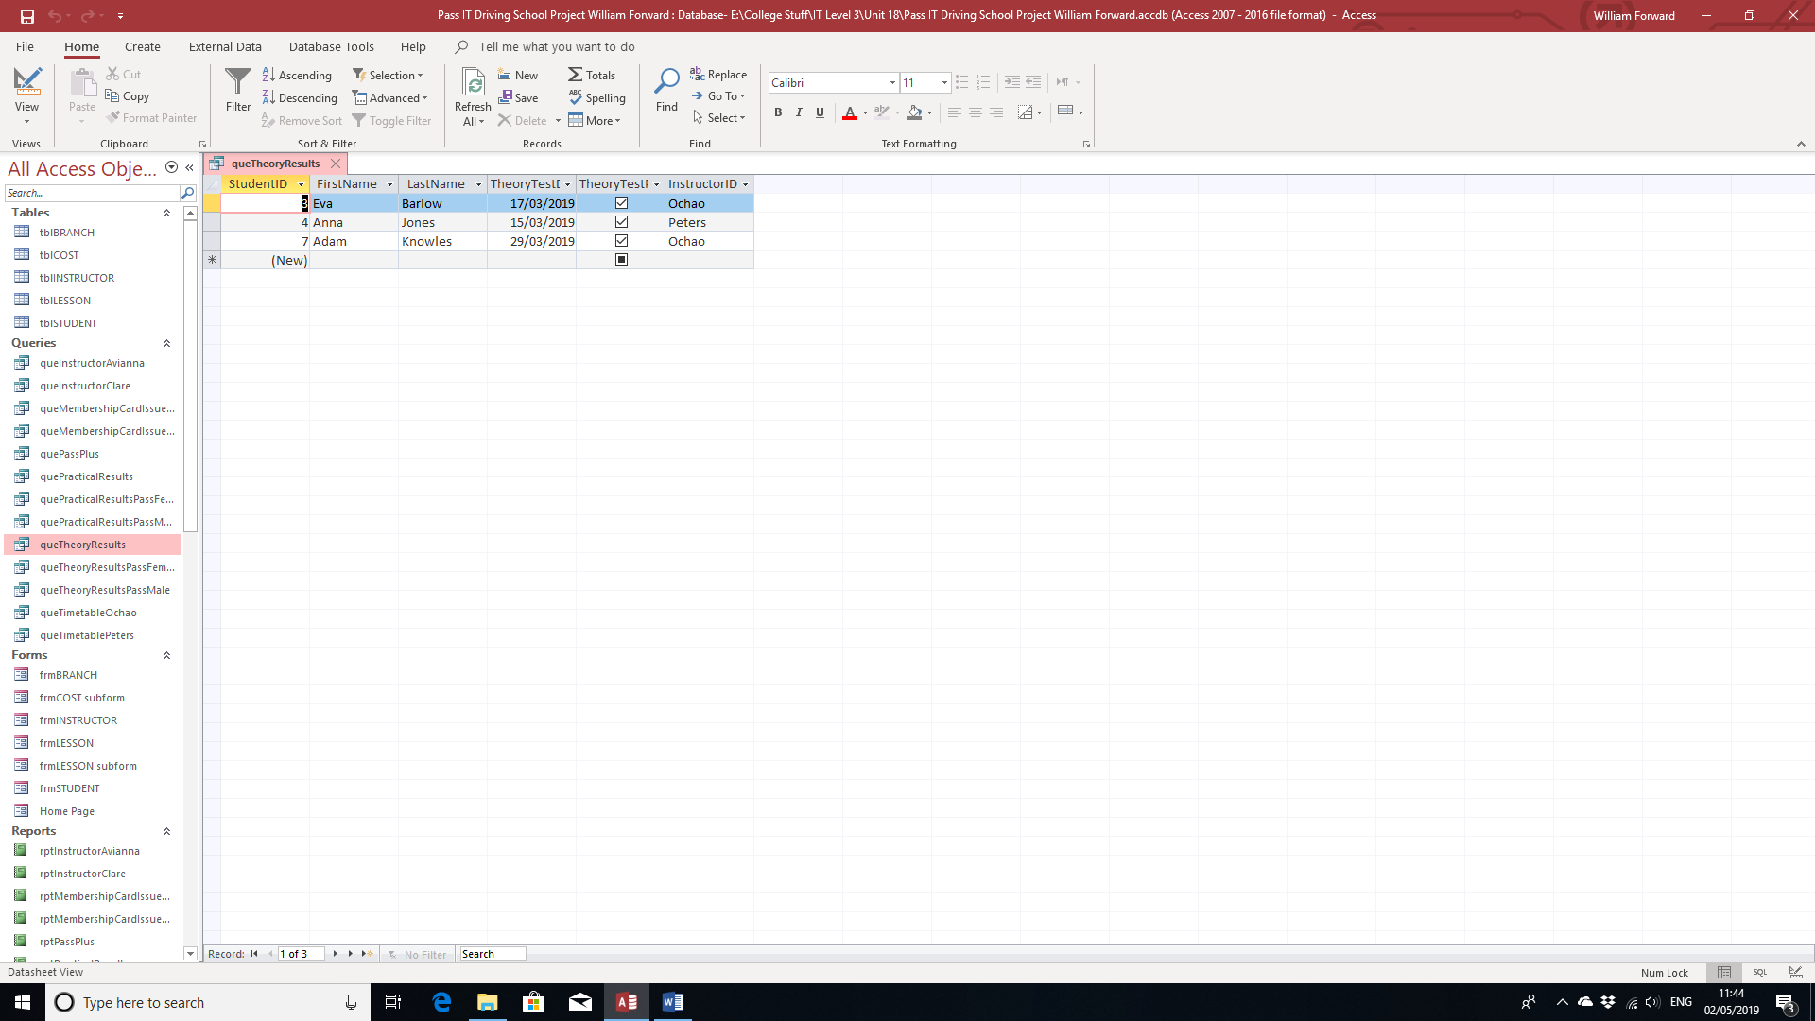

Query Grid:

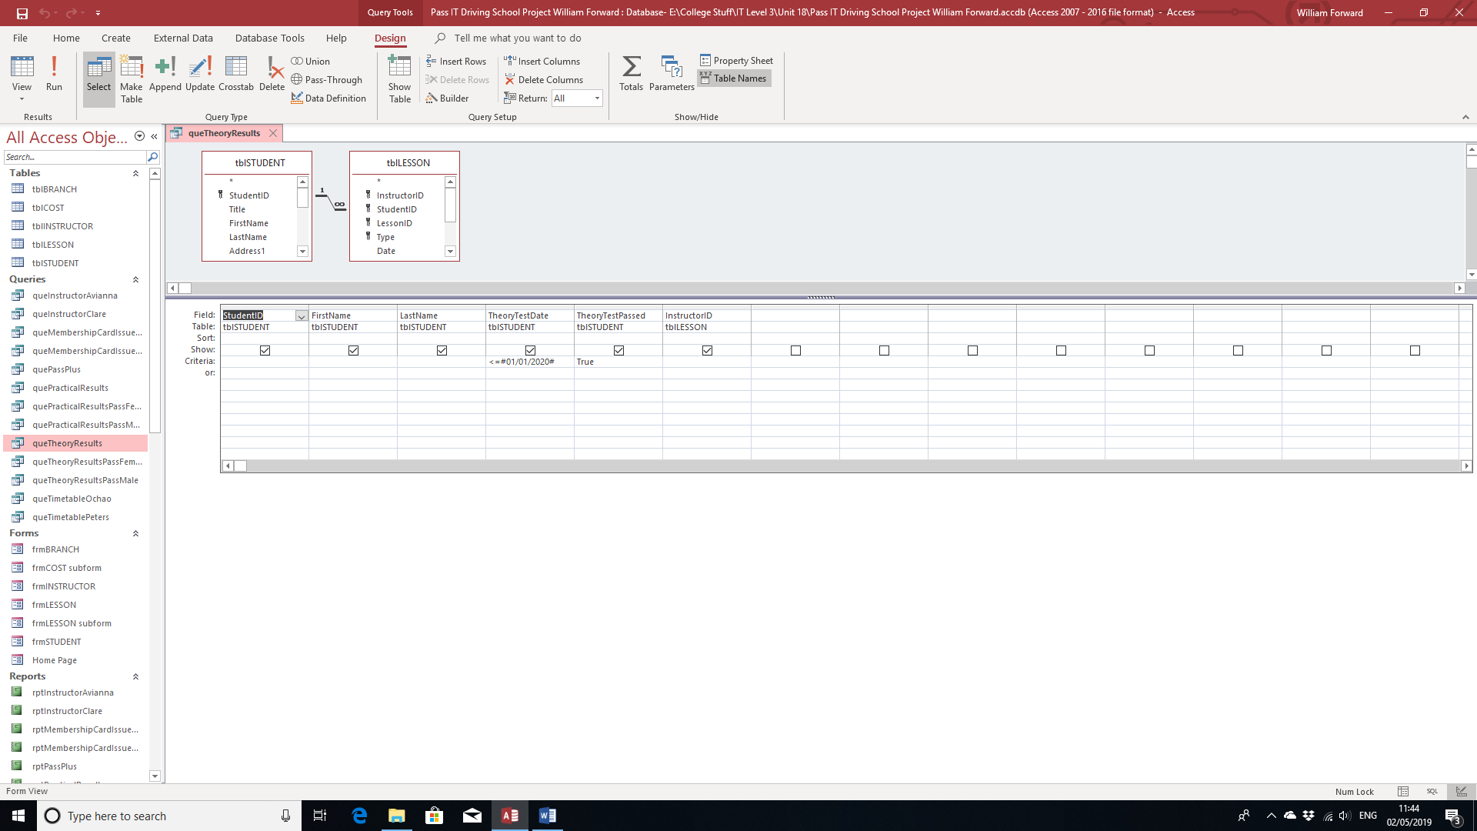

Practical Test Query:

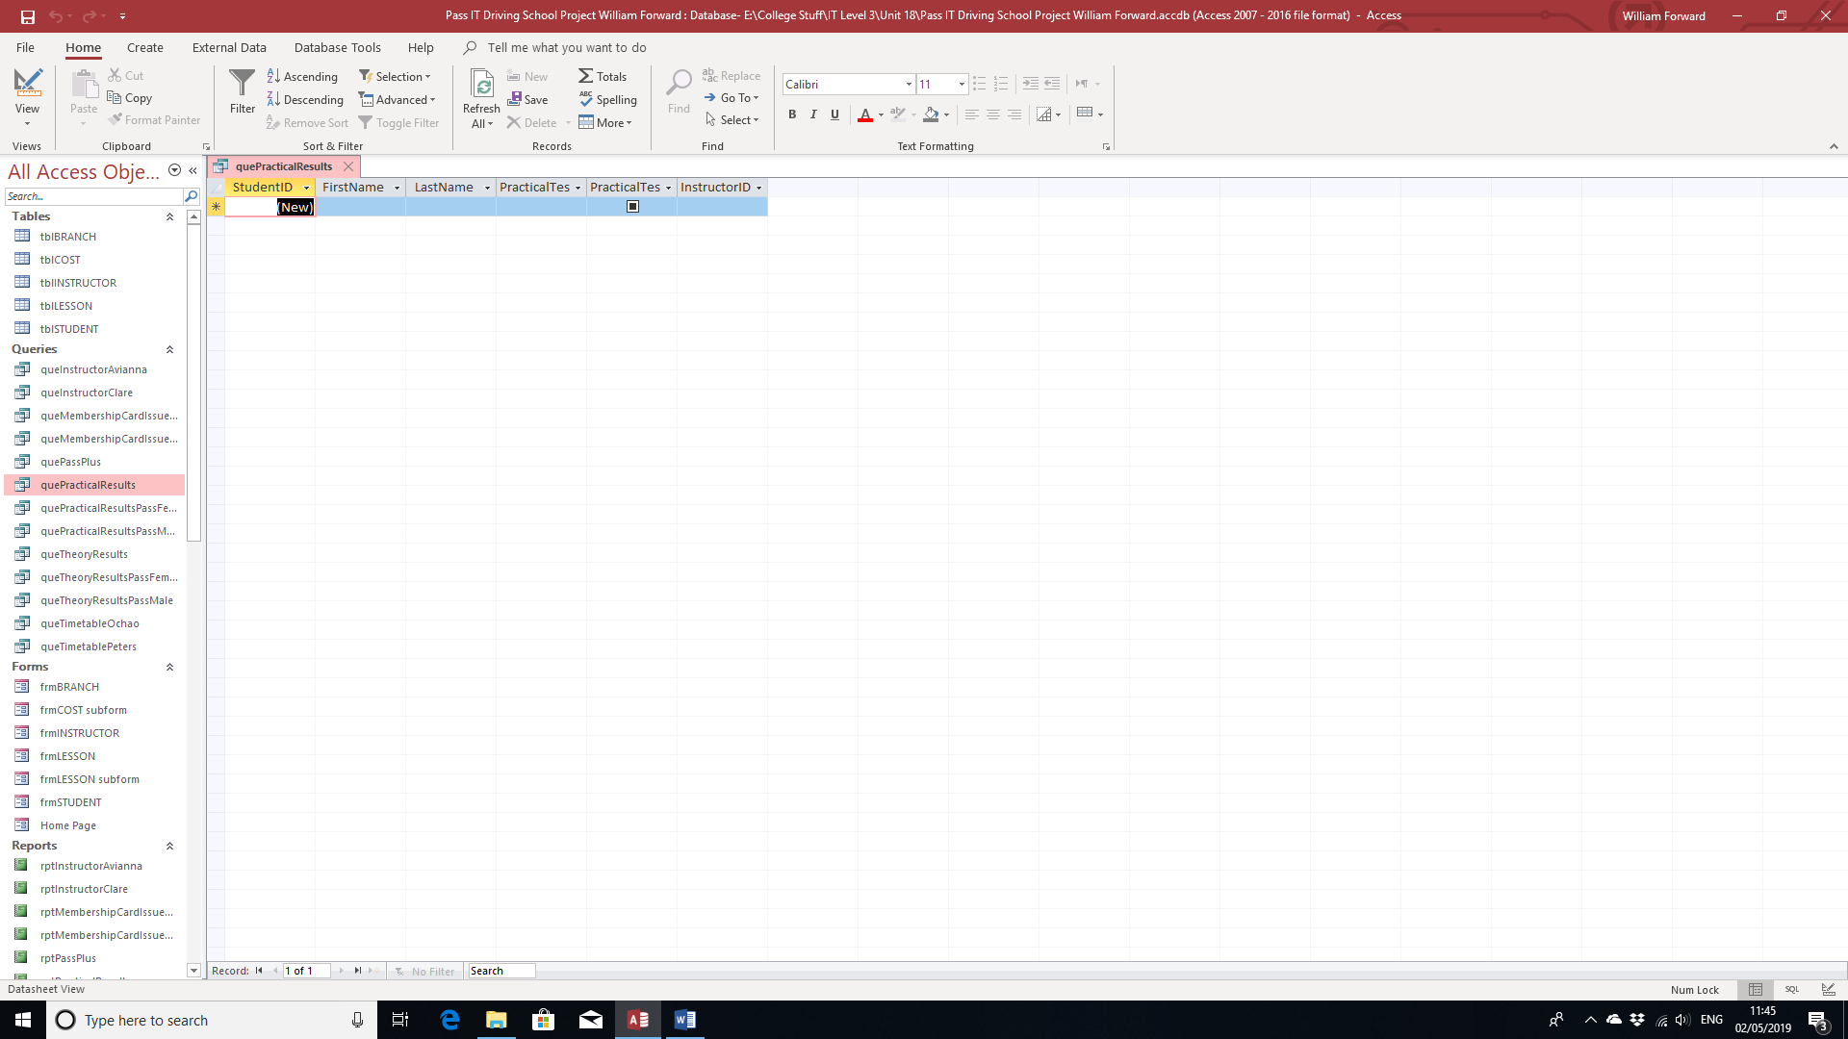

Query Grid:

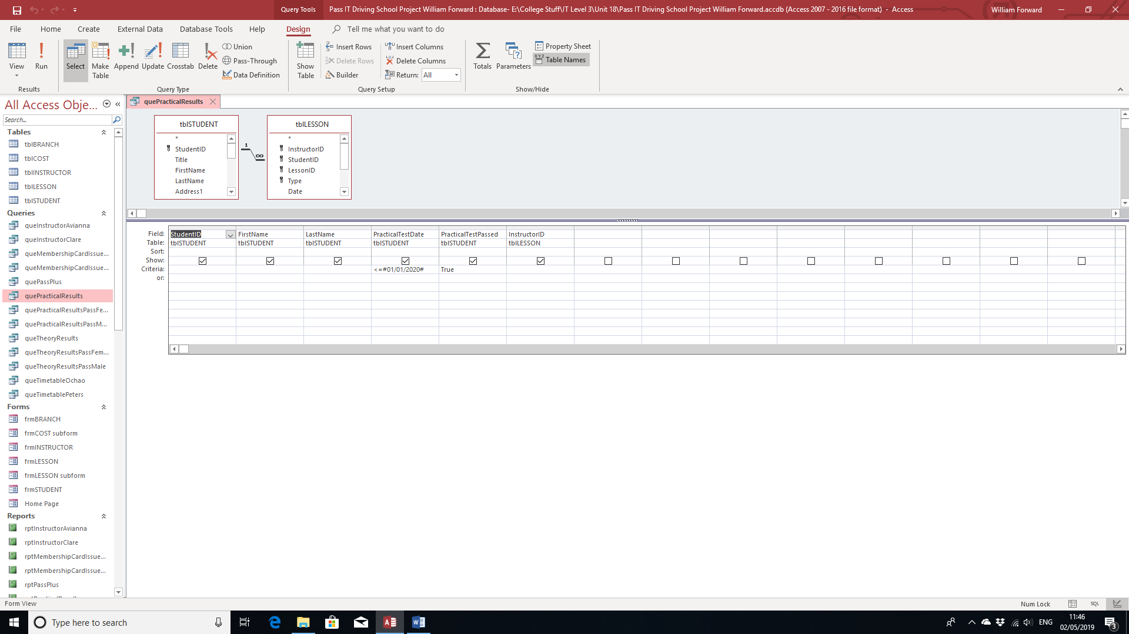

Theory Test Results Male:

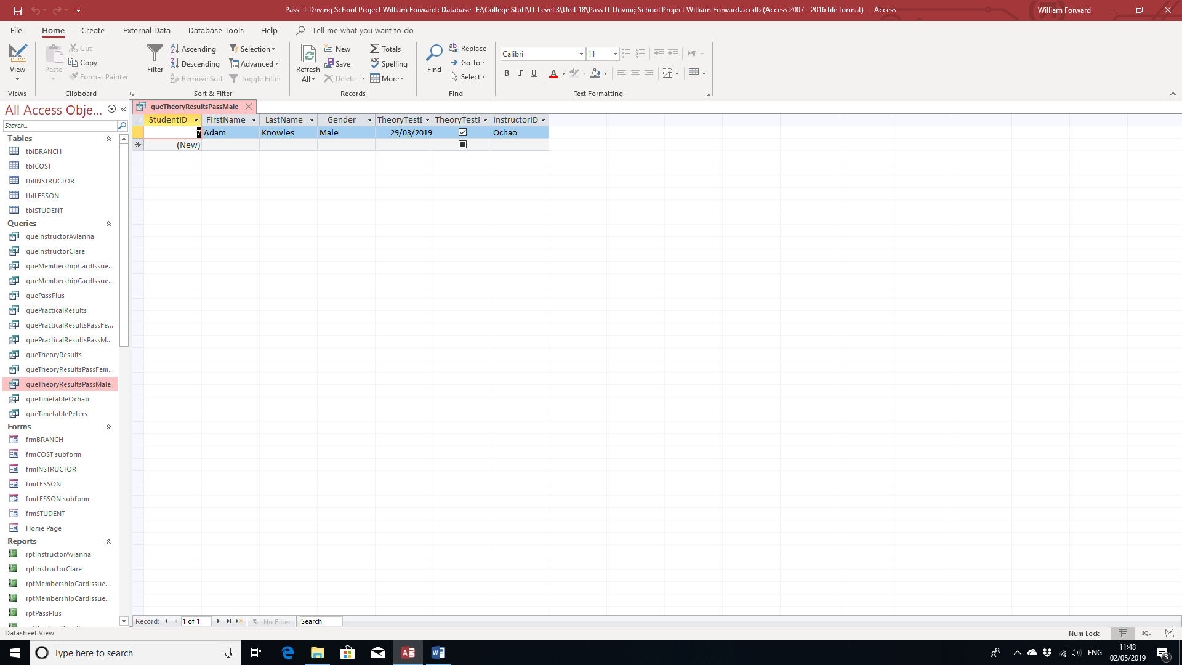

Query Grid:

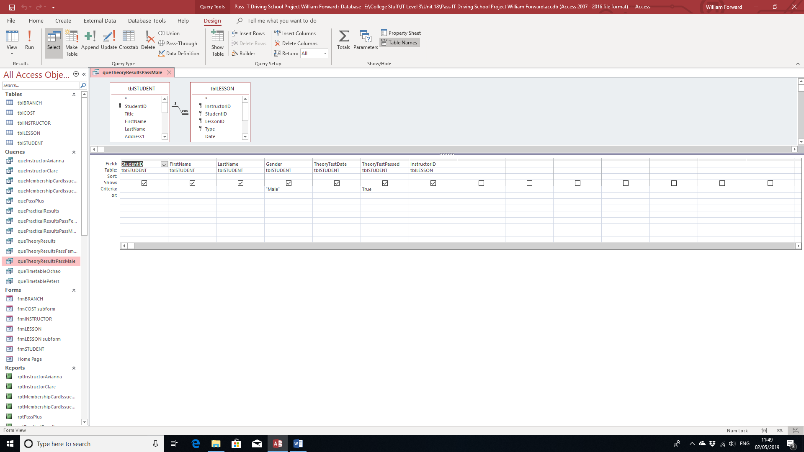

Theory Test Results Female:

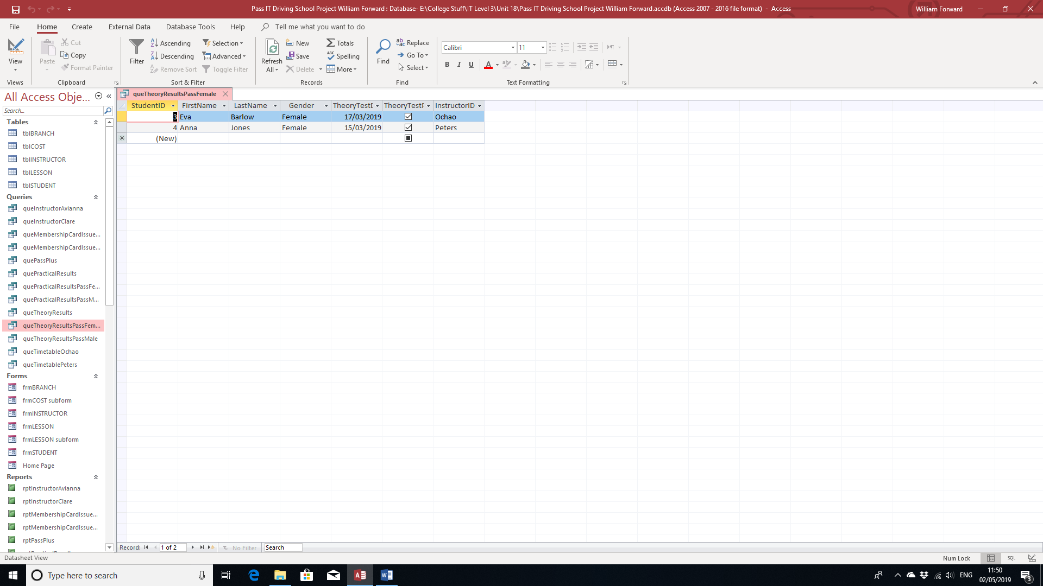

Query Grid:

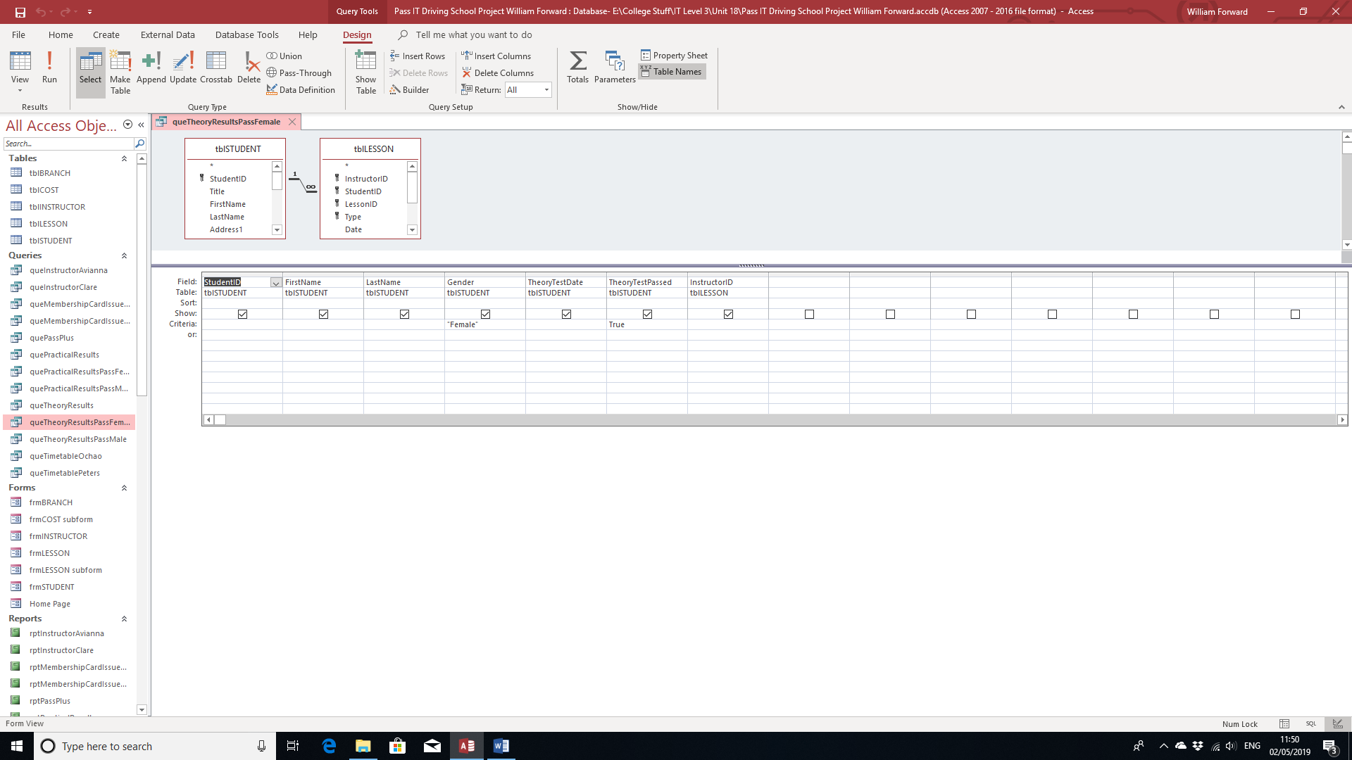

Practical Test Results Male:

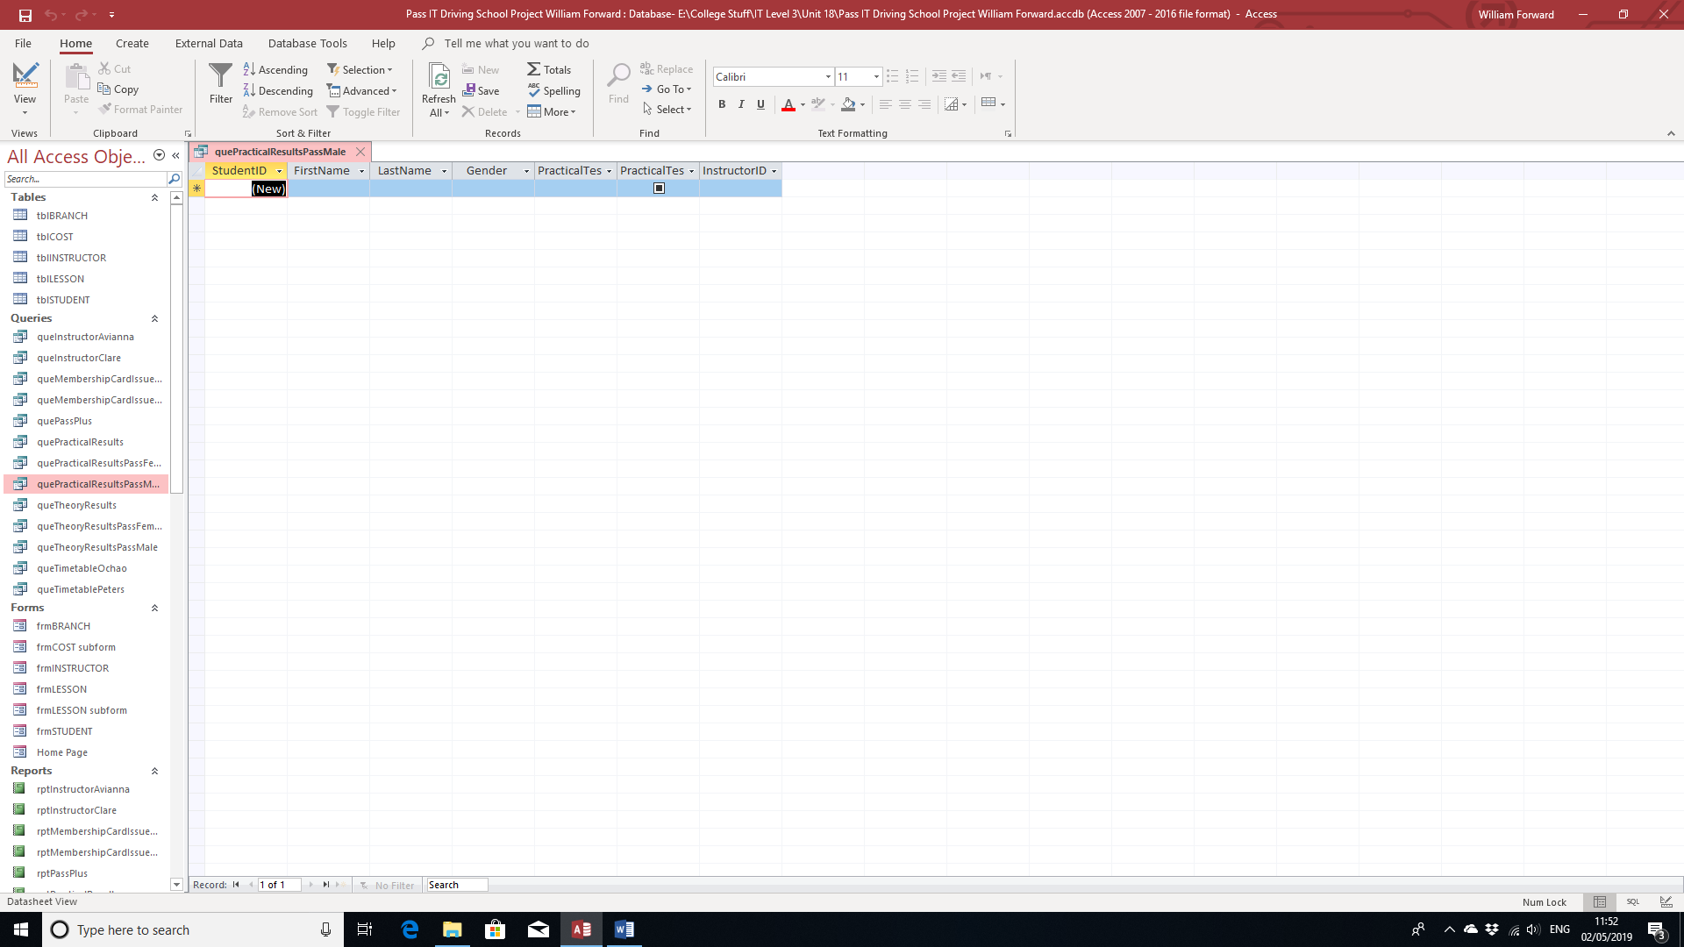

Query Grid:

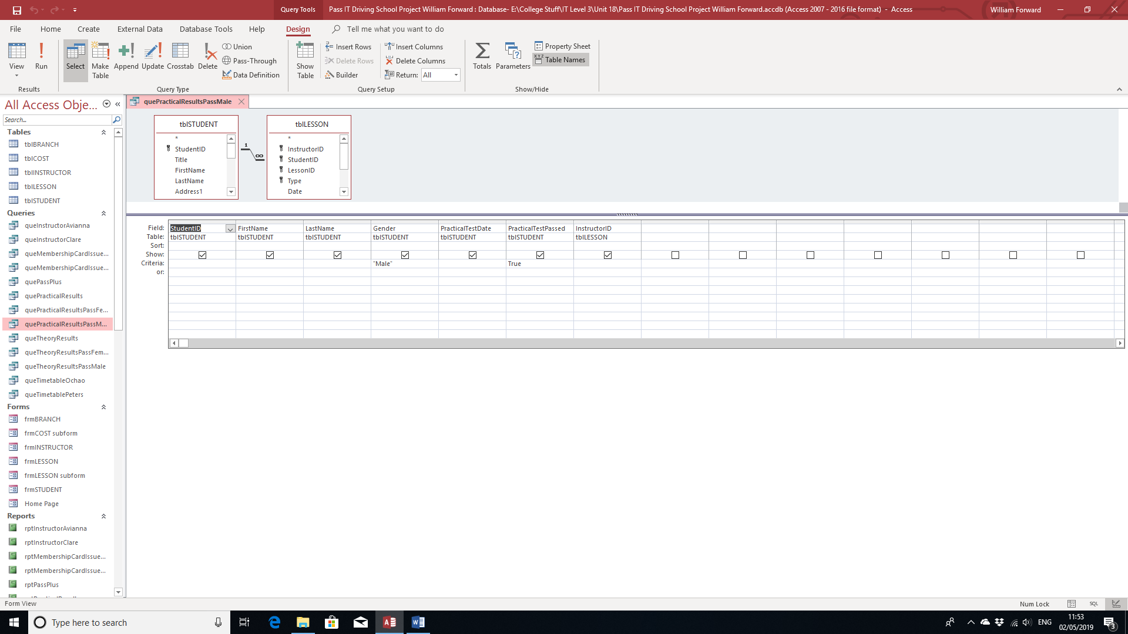

Practical Test Results Female:

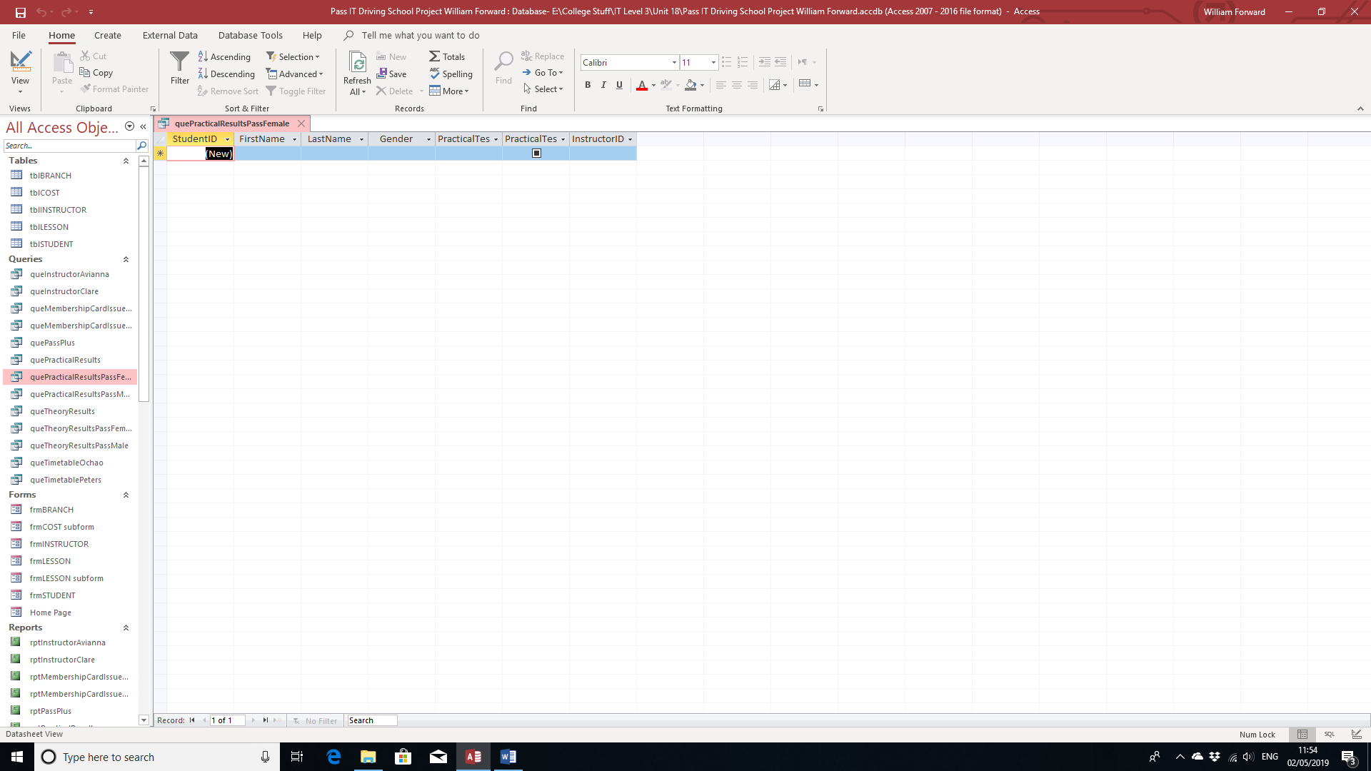

Query Grid:

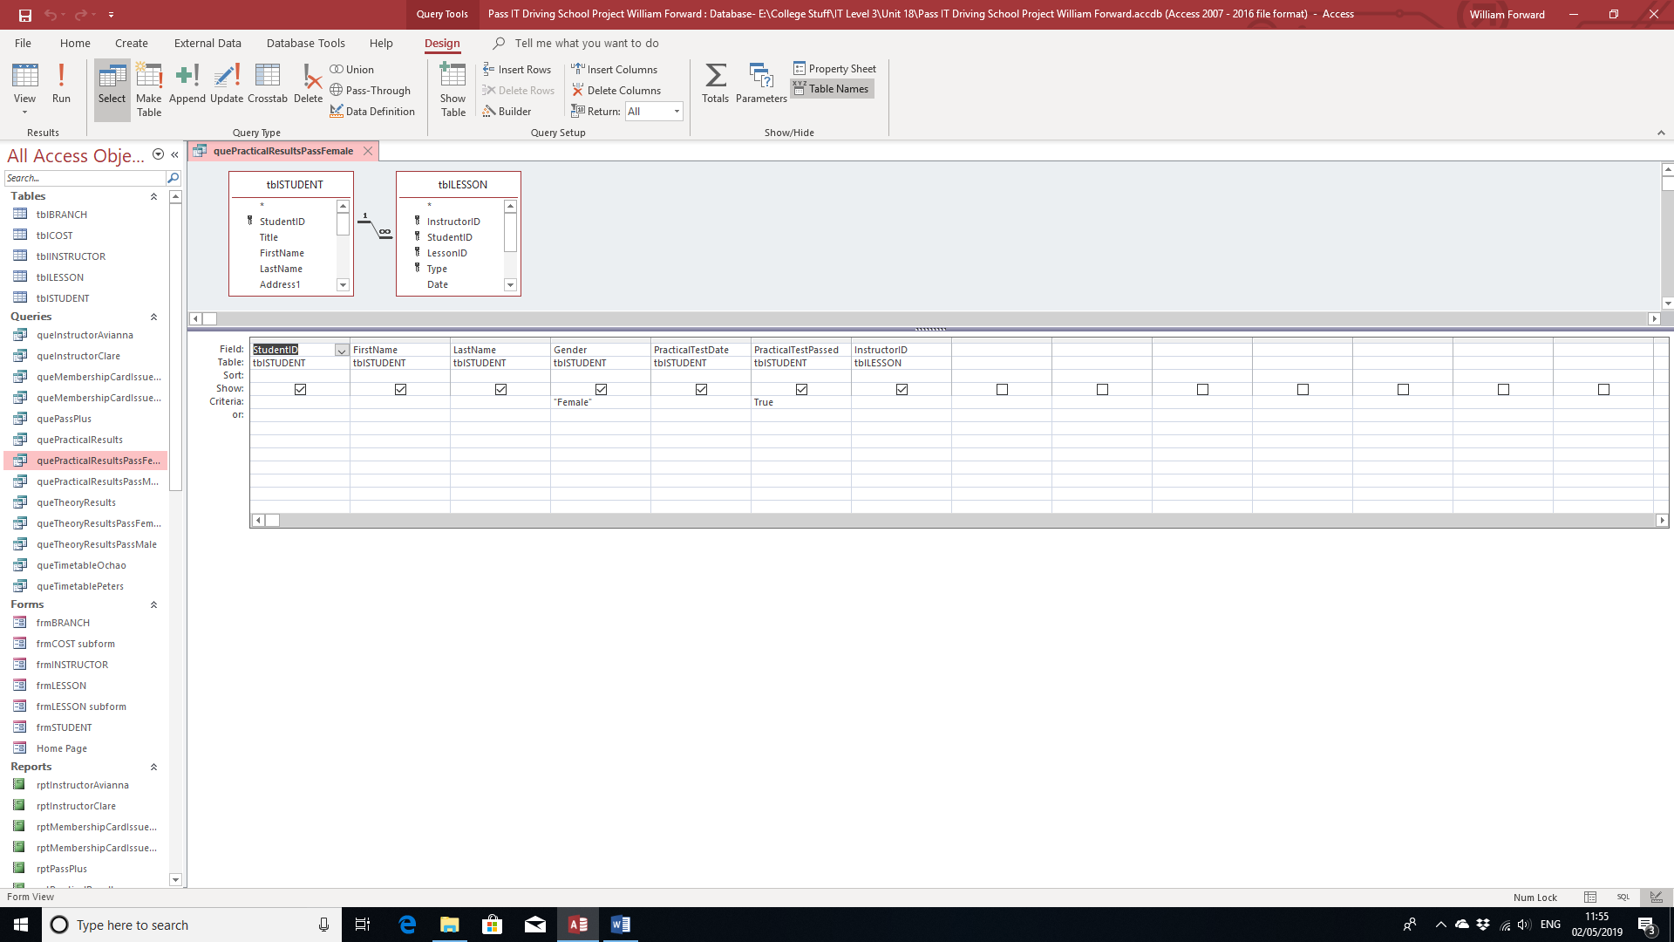

Avianna Ochao’s Query:

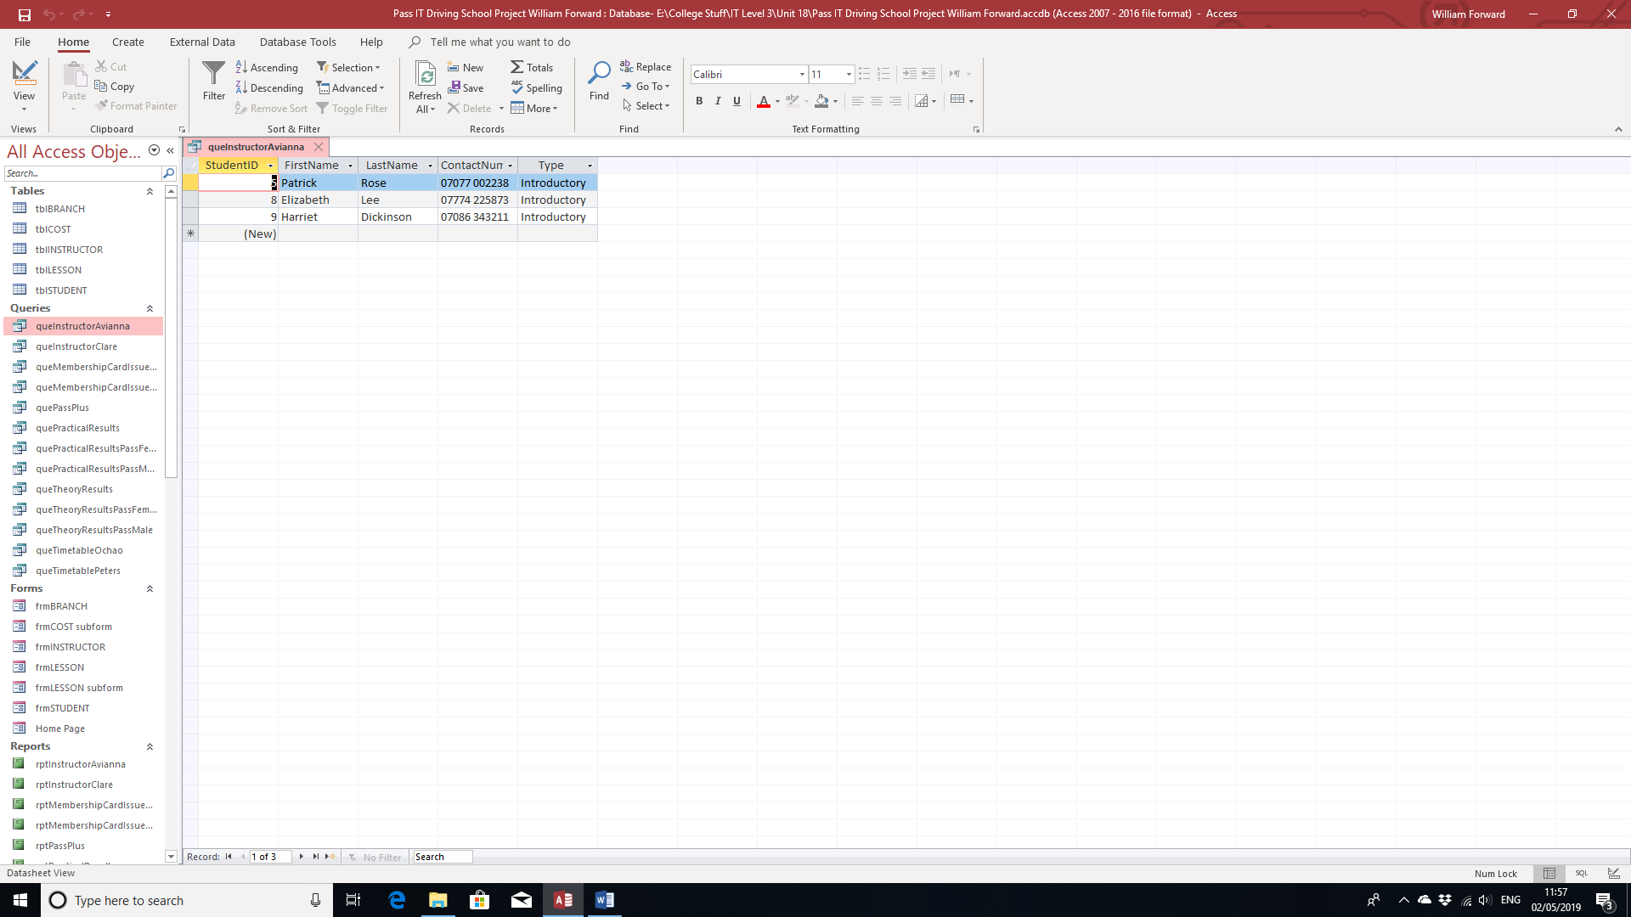

Query Gird:

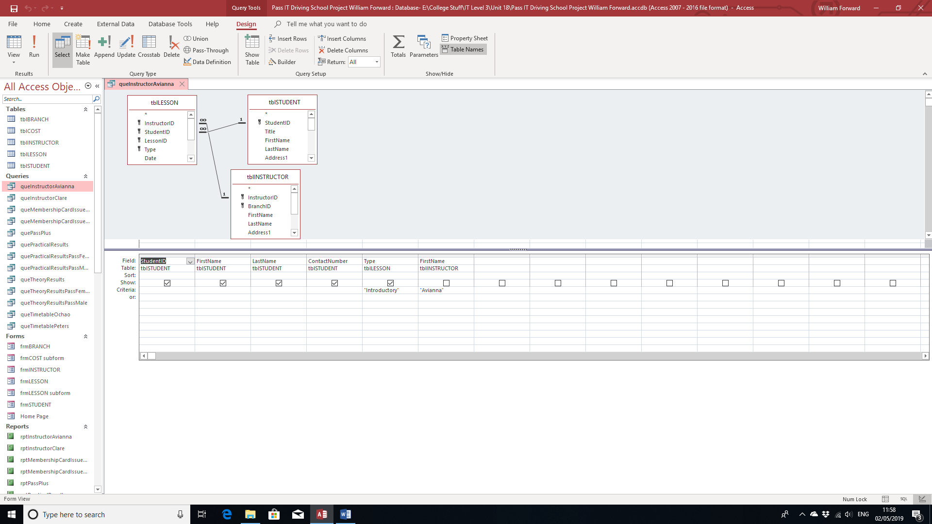

Clare Peters’ Query:

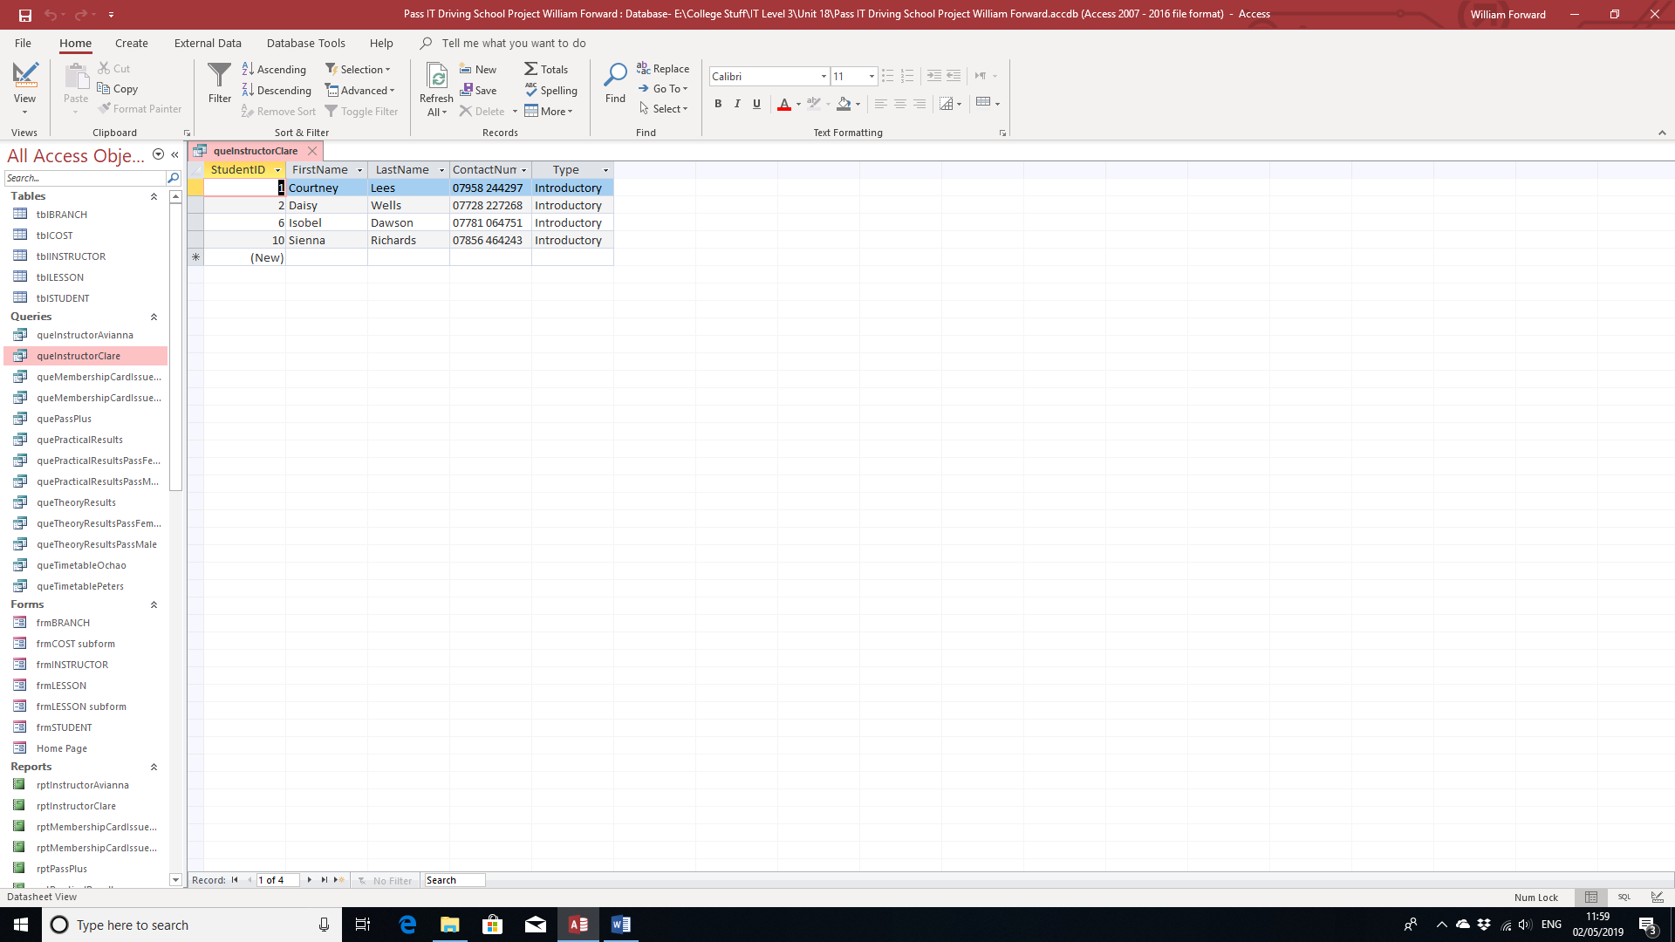

Query Grid:

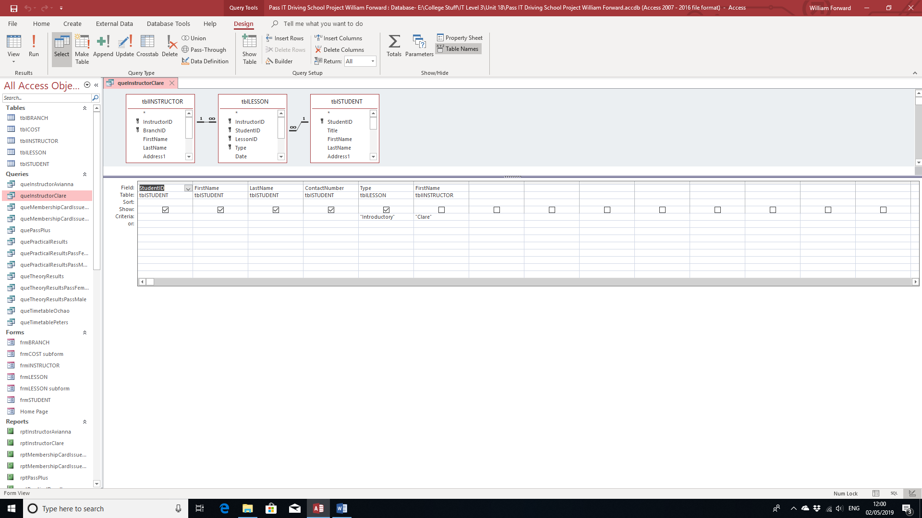

Male Membership Card Query:

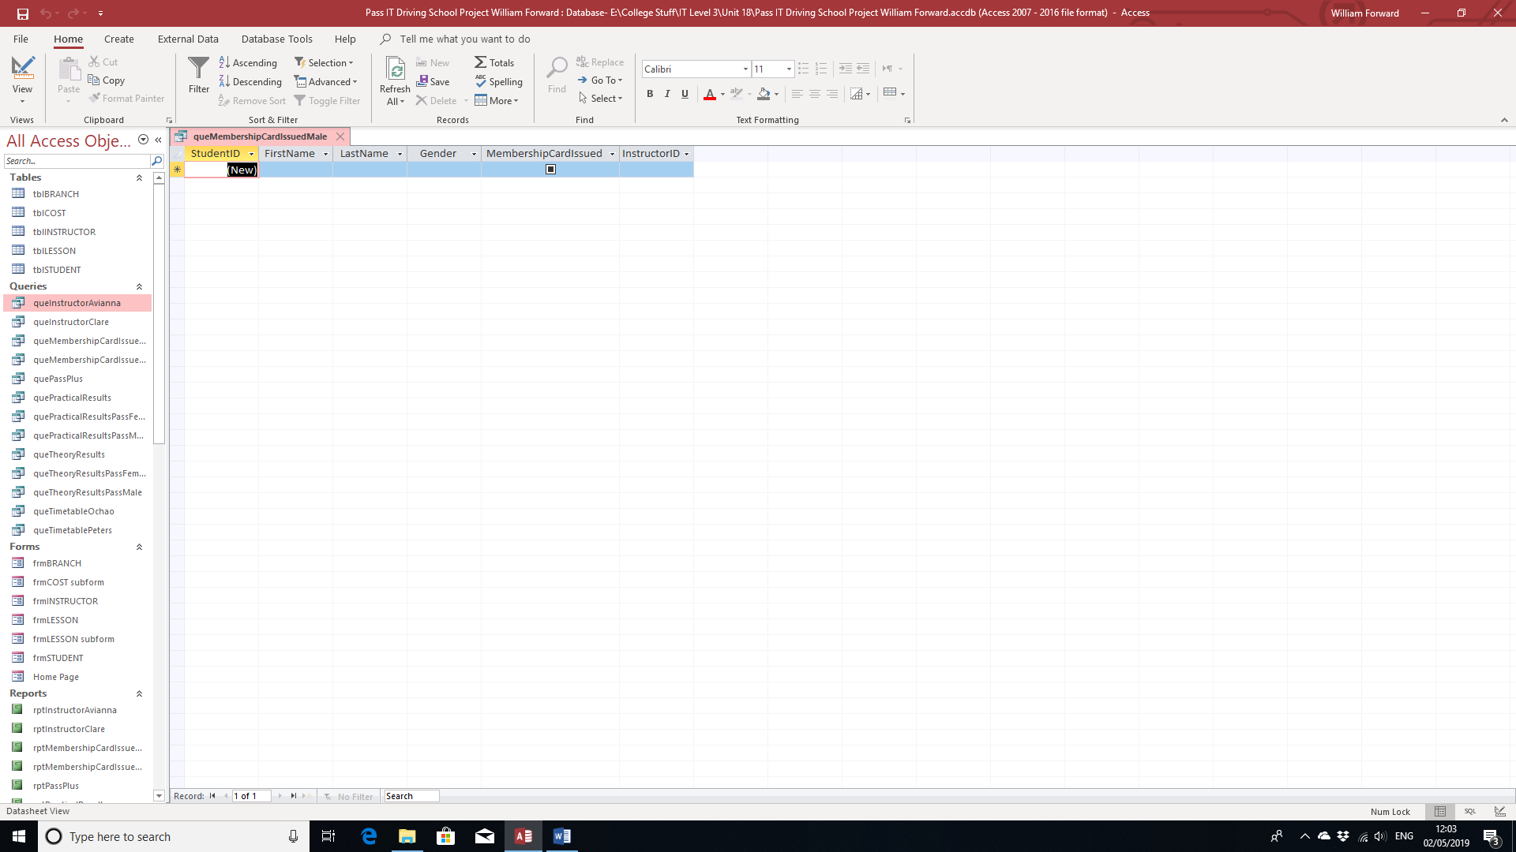

Query Grid:

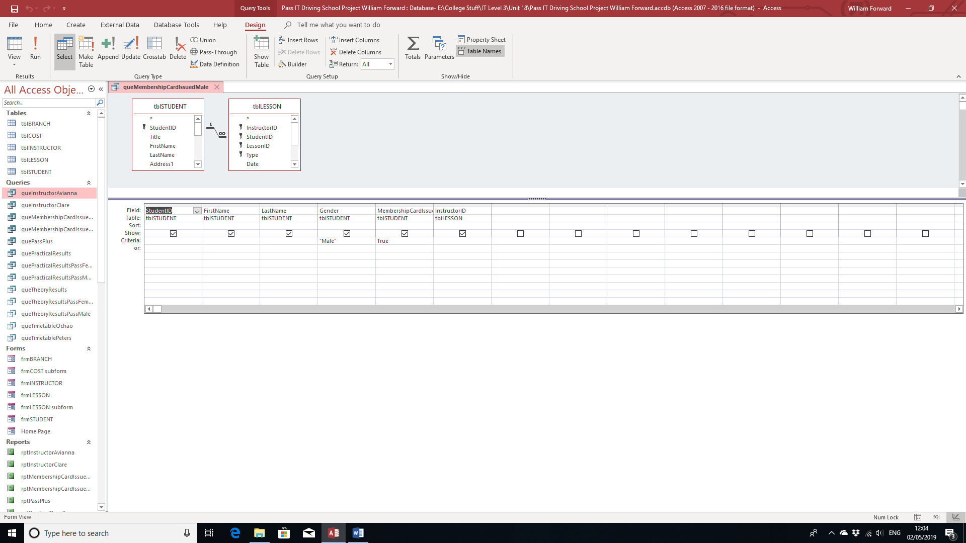

Female Membership Card Query:

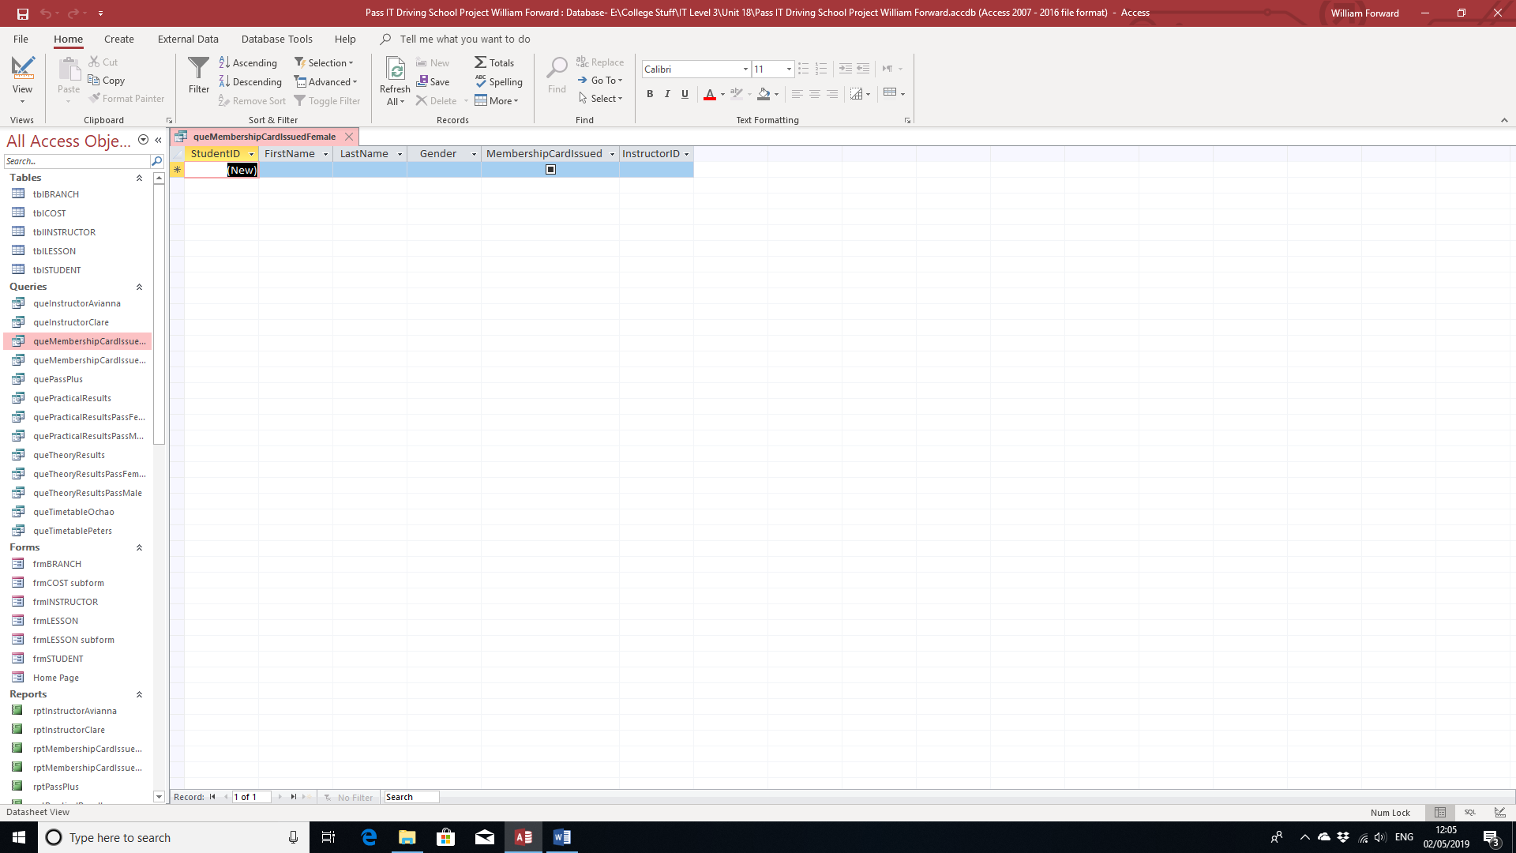

Query Grid:

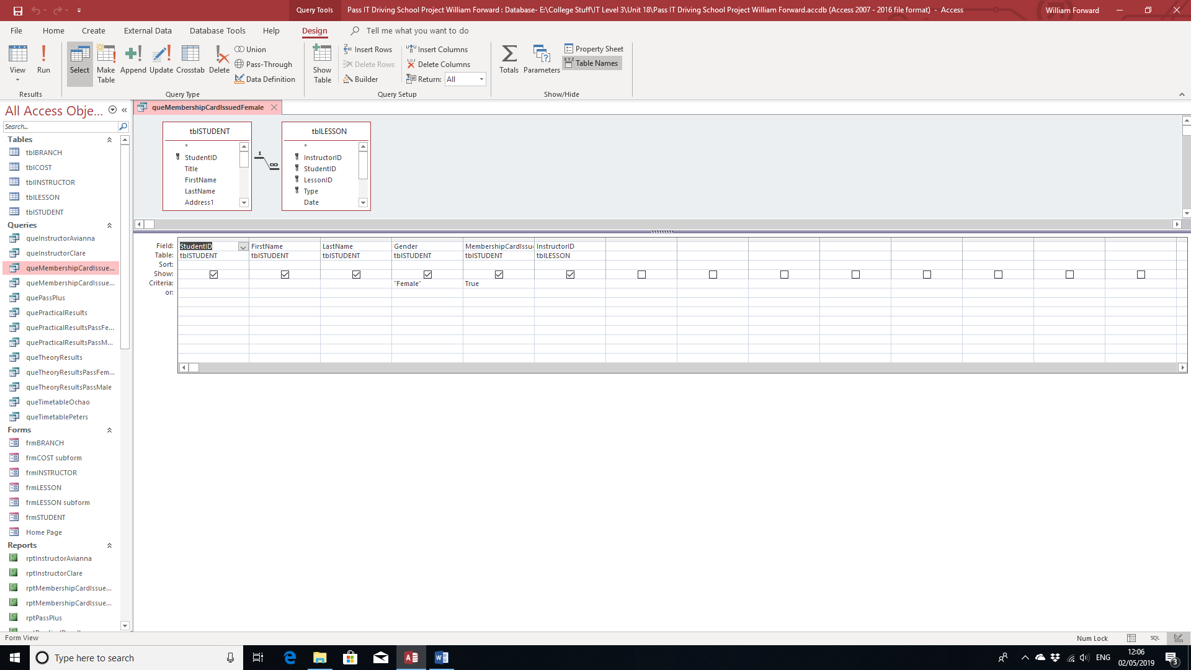

Pass Plus Results:

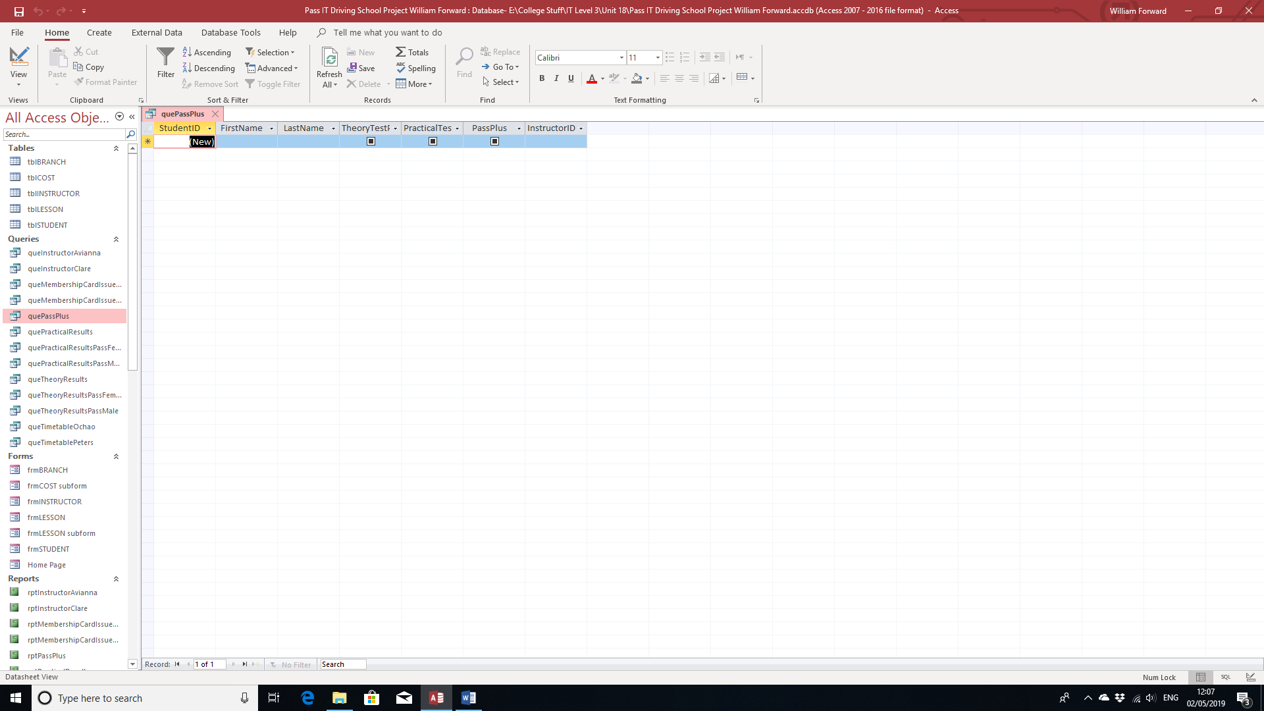

Query Grid:

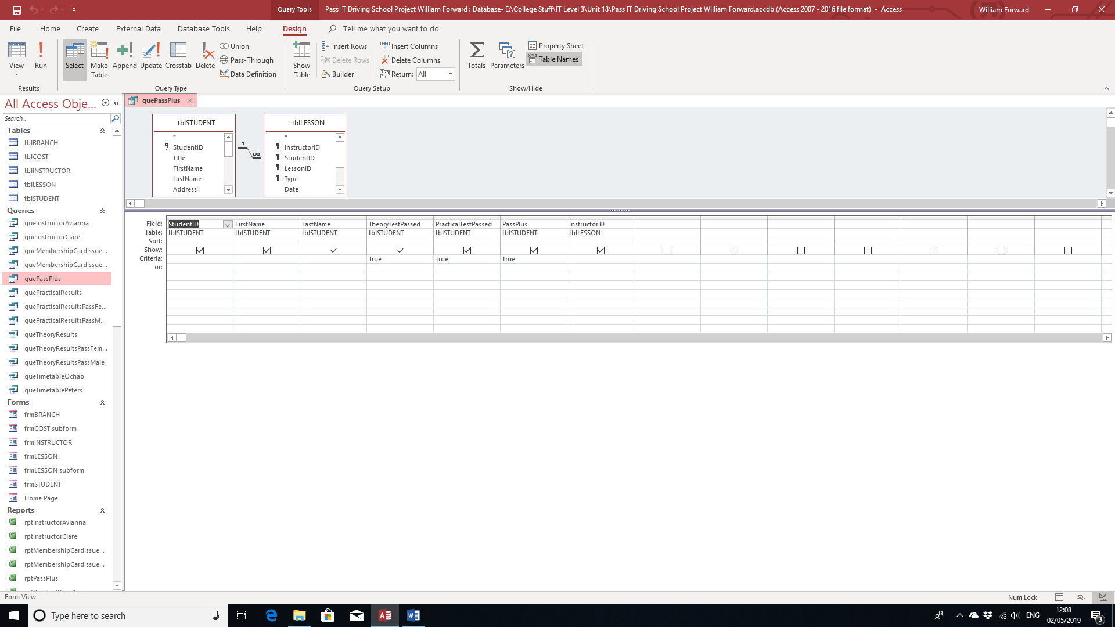

Avianna Ochao’s Timetable:

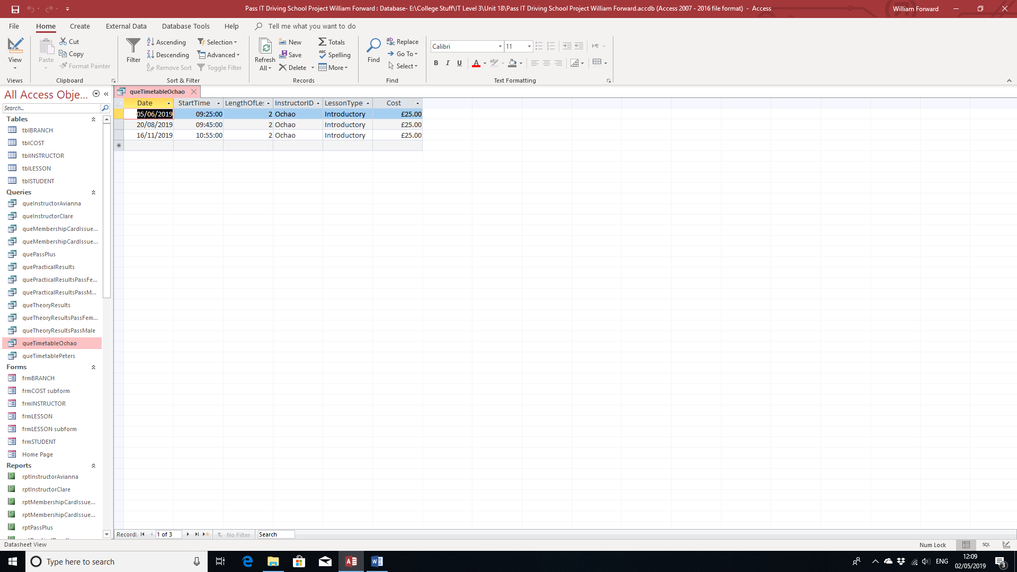

Query Grid:

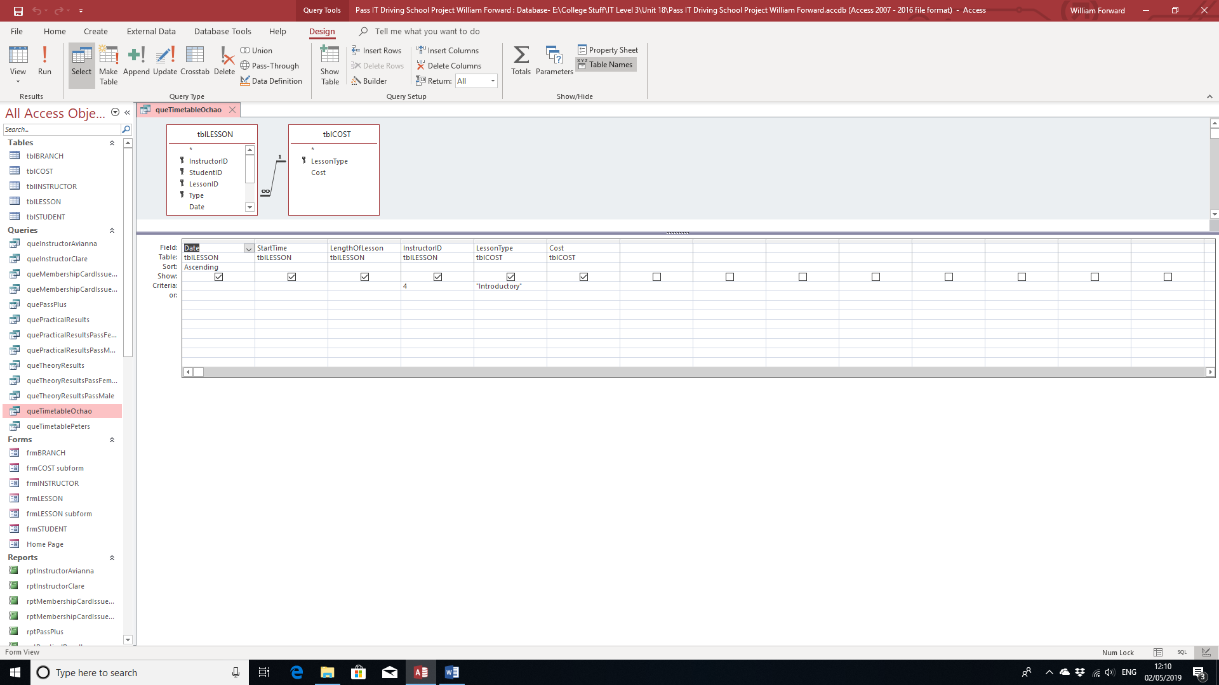

Clare Peters’ Timetable:

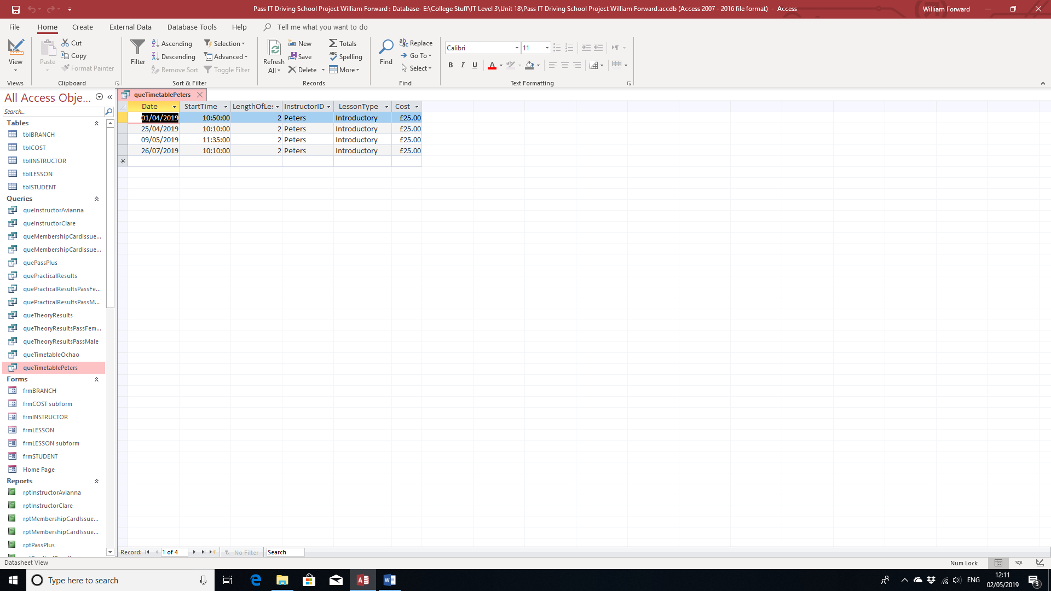

Query Grid:

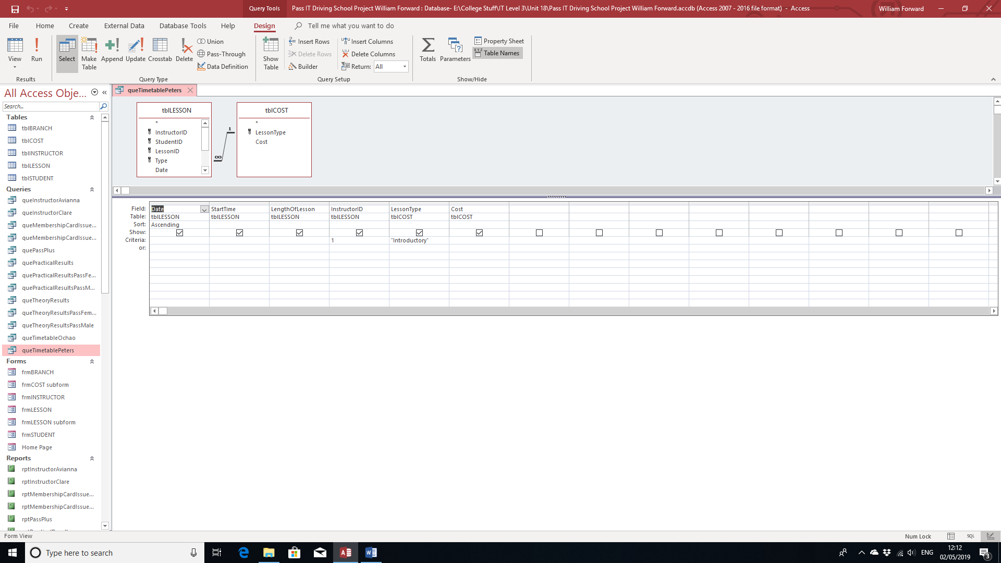

I have also printed out reports of these queries.

In addition, I have exported data from the student table into a spreadsheet file.

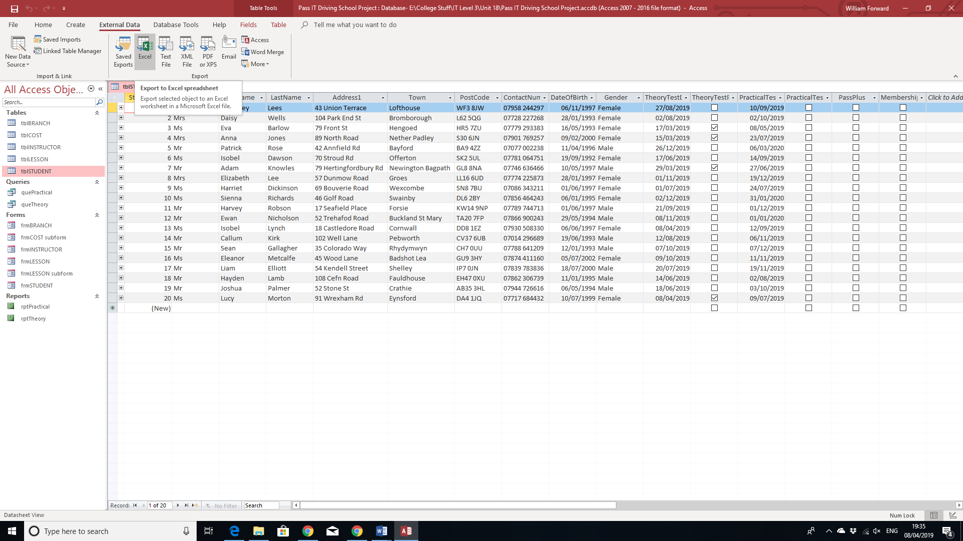

Firstly, I went to External Data and clicked on “Excel” under “Export”, to export the table to an Excel Worksheet.

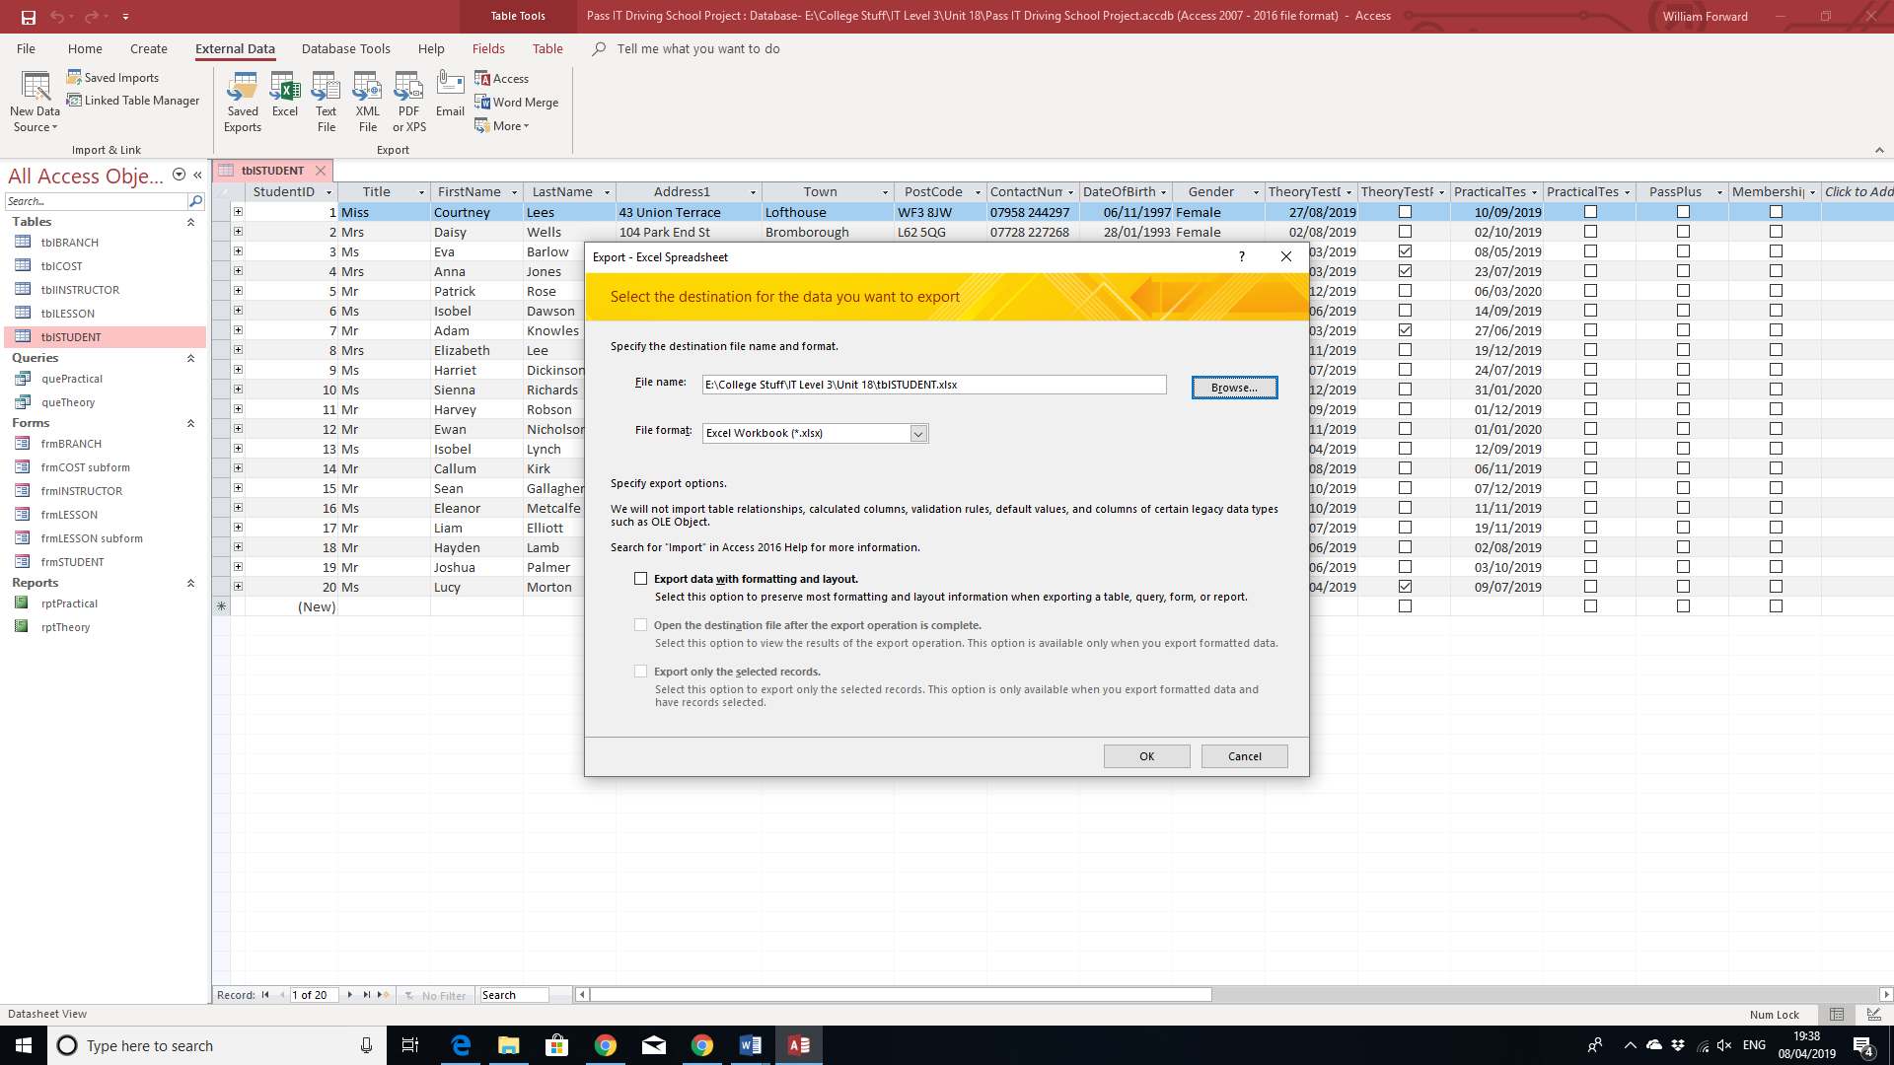

Next, I browsed where I want to save the file and clicked OK.

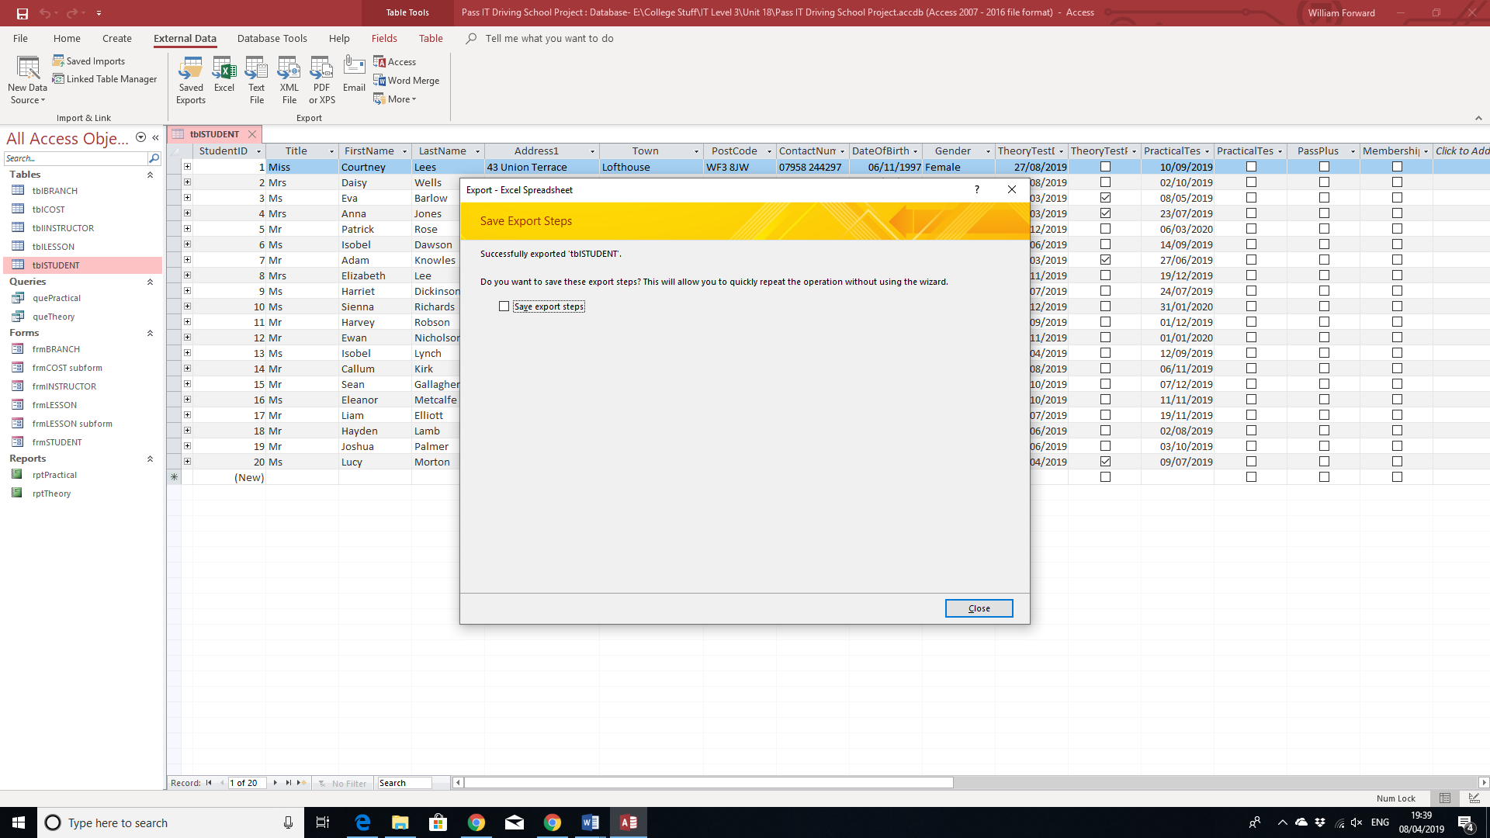

At this page, I clicked Close.

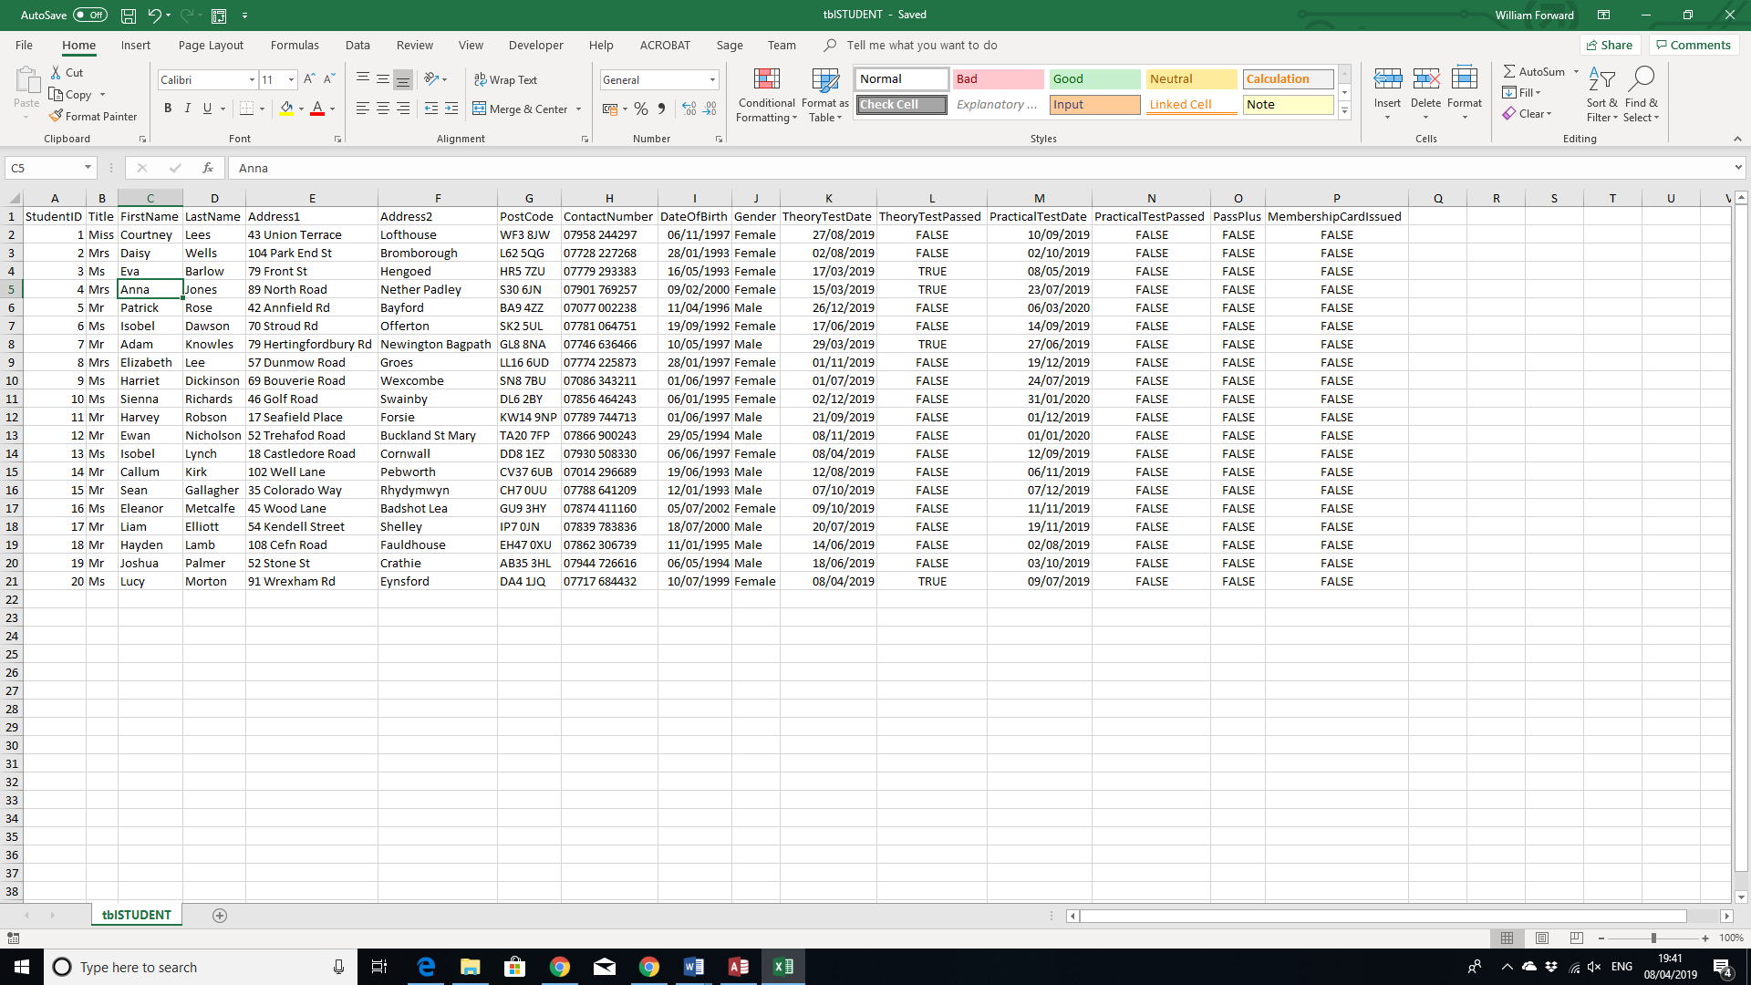

Here is the student table on Excel.

I have also exported the Theory Test Query to a text file.

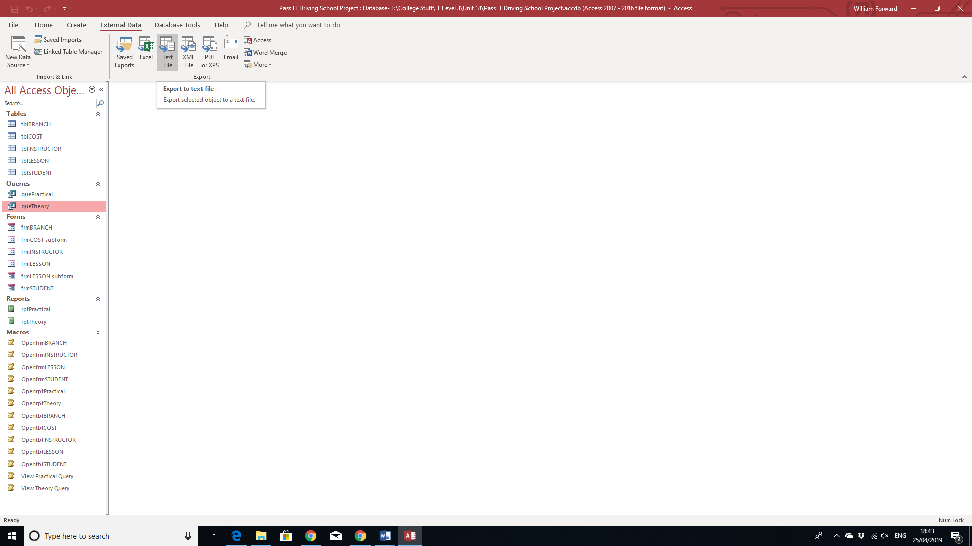

The process is pretty much the same, but this time, I clicked on “Text File”.

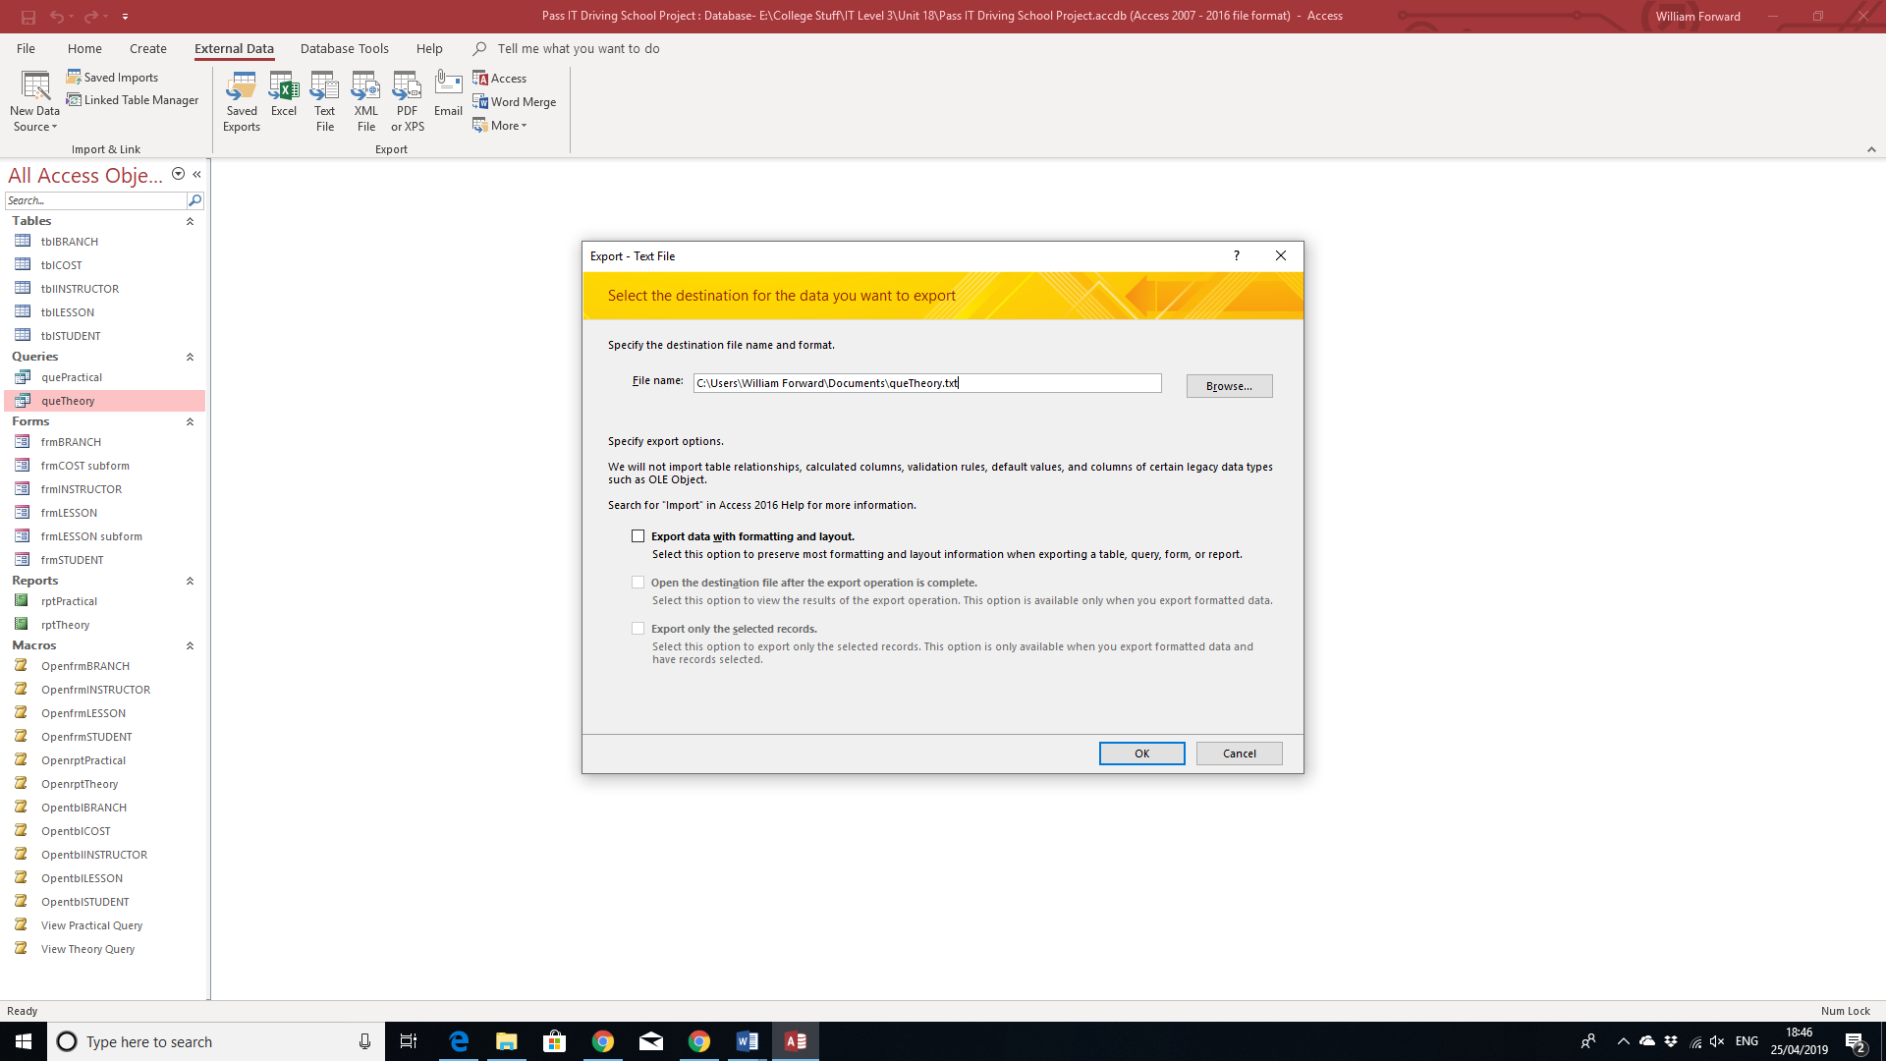

This is also the same, I browsed where I want that file and clicked OK.

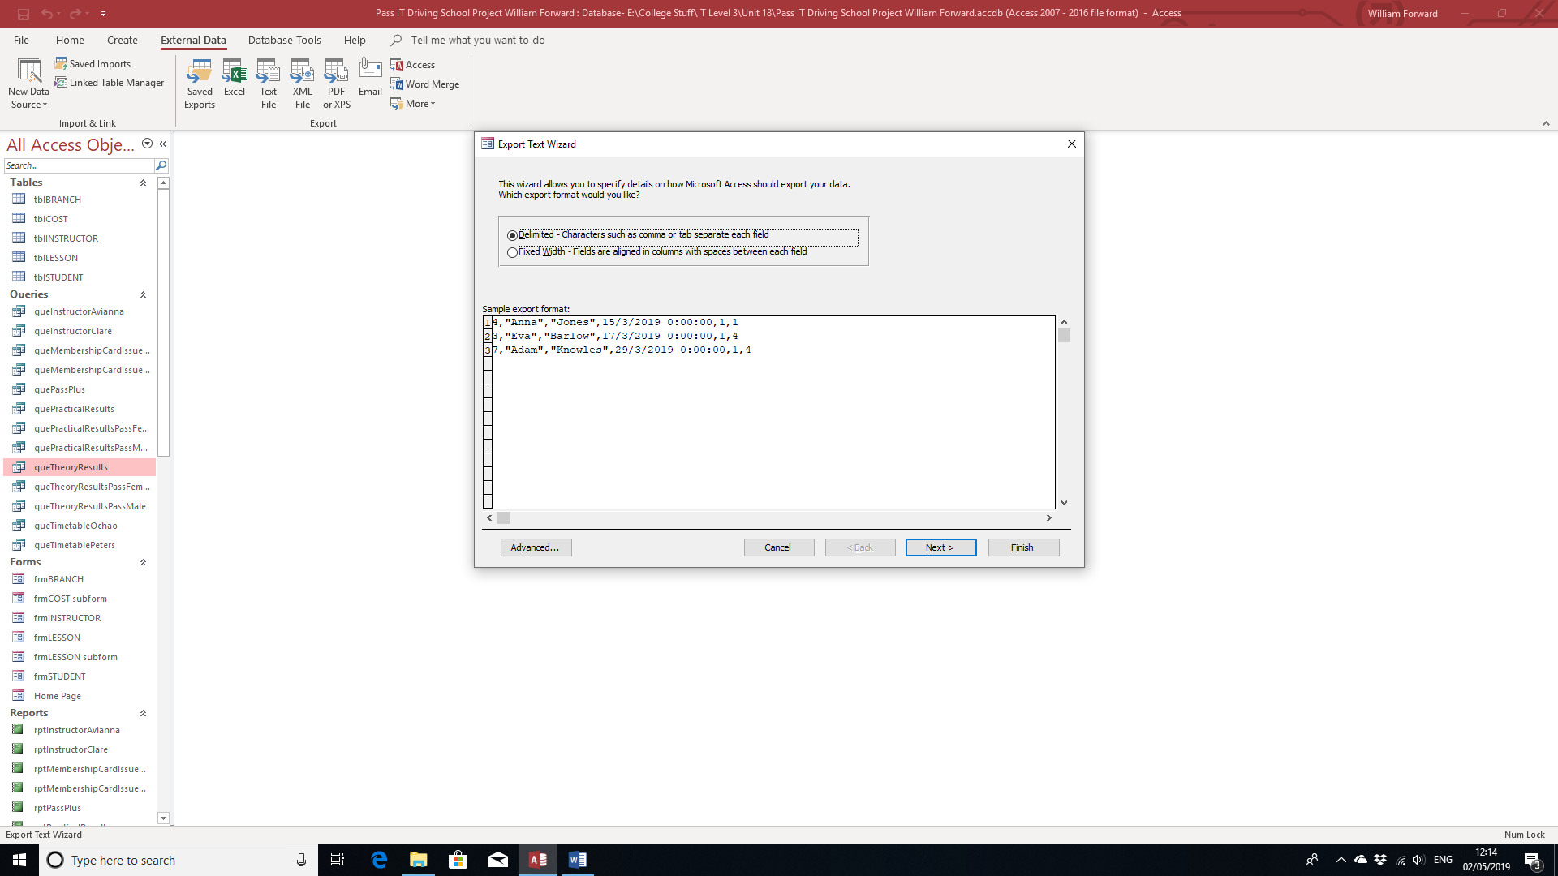

In here, I specified details on which export format I would like.

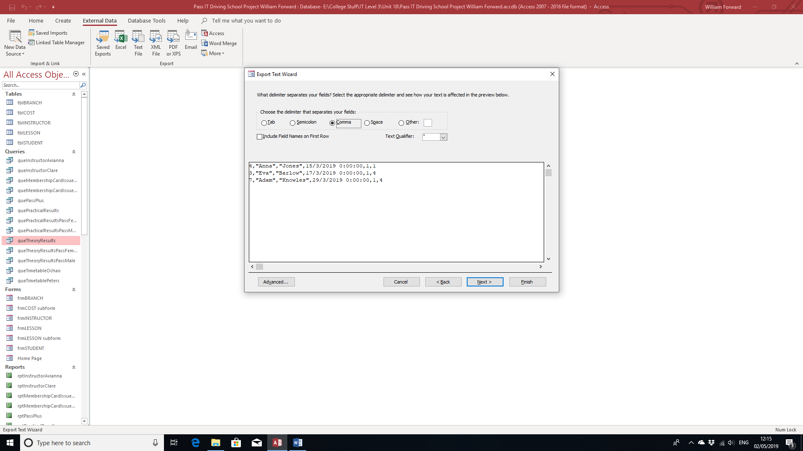

In here, I chose the delimiter that separates my fields.

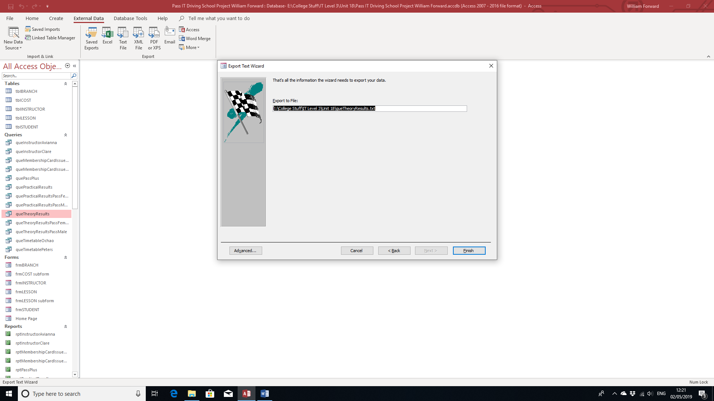

After that, I clicked Finish.

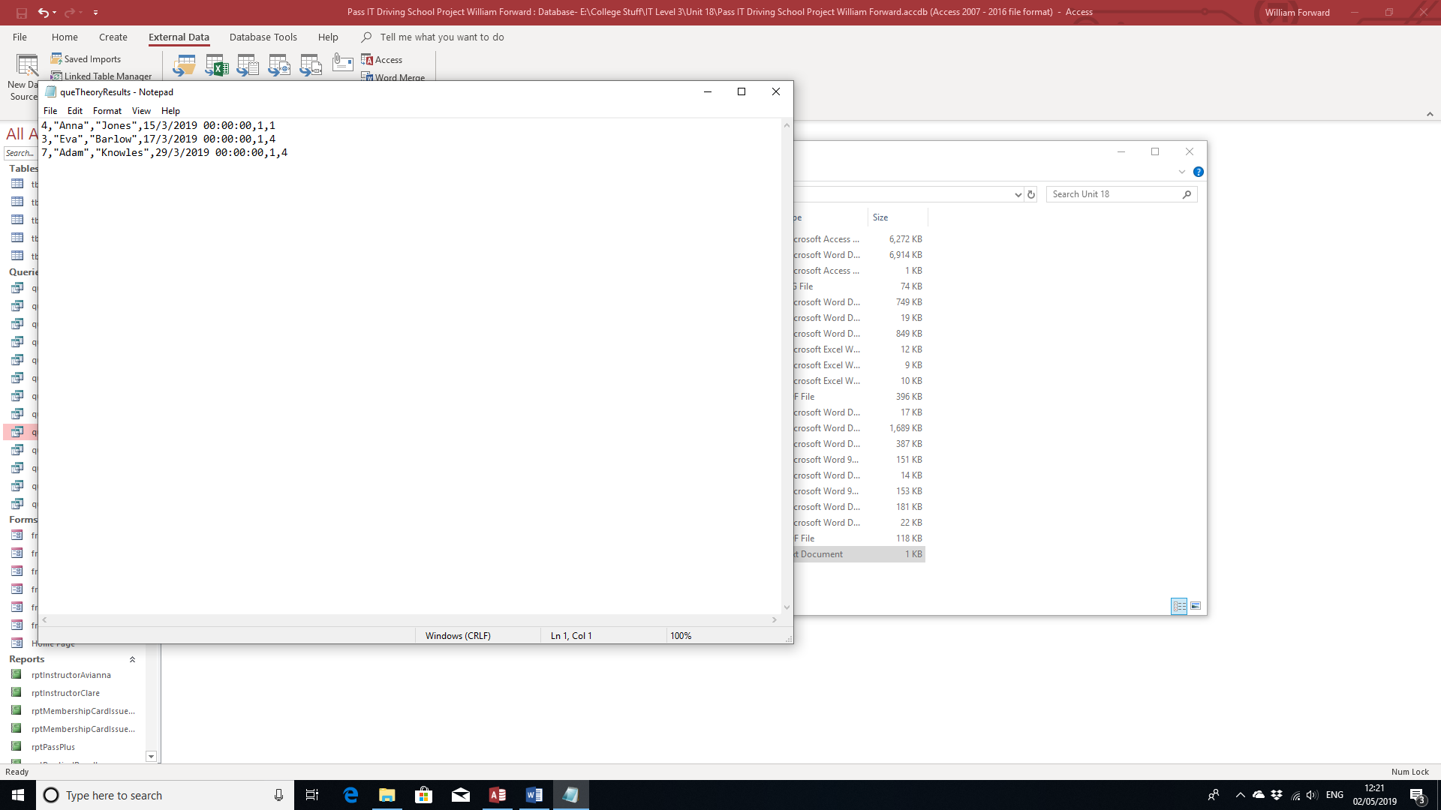

Here is the text file.

I would also like to mention that I have added automated functions to the database to improve functionality and aid user experience. I have done so using macros.

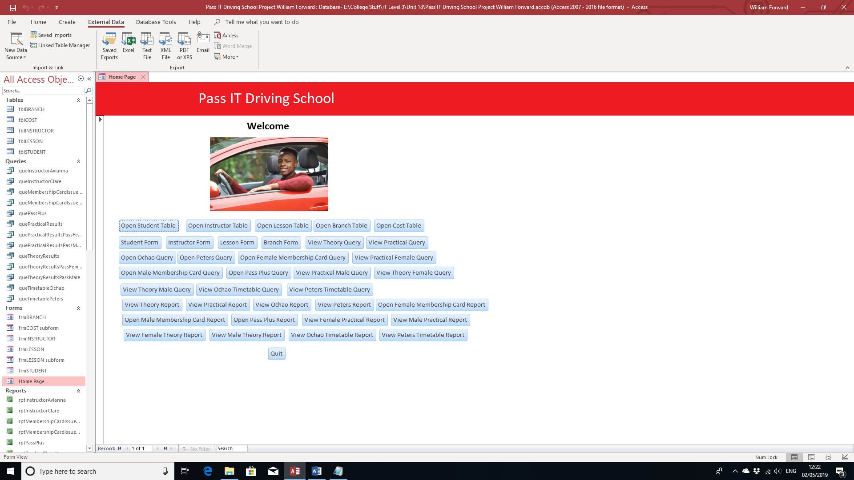

As you can see on the home page I’ve created, there are a lot of buttons. All these buttons have macros attached to make them perform certain tasks, which in this case is mostly navigation, except for the “Quit” button, which closes the program. Each button navigates to every query, report, any other form and the table attached to their respective form. I did this to improve the functionality of moving to other pages as well as making the user experience much easier. The buttons that navigate the user to a specific table and other forms can be seen on just about every form.









Here is the test log for the entire database.

**Test Log:**

|  |  |  |  |  |  |  |  |
| --- | --- | --- | --- | --- | --- | --- | --- |
| **Test No:** | **Test Data** | **Purpose** | **Expected Result** | **Actual Result** | **Pass** | **Fail** | **Re-Test?** |
| 1 | Enter a New Student. | Test Input Function. | New Record is Entered. | Everything Seems fine, but contact number isn’t entered the way I want it to be. |  | ✓ | Yes |
| 2 | Enter Student’s Contact Number. | Test New Input Mask Placed. | Phone number is entered the way I want it. | It is entered the way I want. | ✓ |  | No |
| 3 | Enter the rest of the student details. | Test Input Function. | New Record is Entered. | Now Everything is entered the way I expect it. | ✓ |  | No |
| 4 | Enter Branch Details. | Test Input Function. | New Record is Entered. | Everything has been entered to my liking. | ✓ |  | No |
| 5 | Enter Instructor Details. | Test Input Function. | New Record is Entered. | Everything has been entered to my liking. | ✓ |  | No |
| 6 | Enter Student onto Instructor Database. | Test Function of Primary and Foreign Keys. | Record is shown in foreign field. | Everything seems to link together fine. | ✓ |  | No |
| 7 | Enter Branch onto Instructor Database. | Test Function of Primary and Foreign Keys. | Record is shown in foreign field. | Everything seems to link together fine. | ✓ |  | No |
| 8 | Enter a Cost for a Lesson. | Test Input Function. | New Record is Entered. | Enter to way I expect it to. | ✓ |  | No |
| 9 | Importing data from another source. | Test Import Function. | New Records are entered underneath. | New records Are Indeed Entered Correctly. | ✓ |  | No |
| 10 | Find a Record using a Form. | Test Command Button. | Record is found based on user input. | Records can be found easily. | ✓ |  | No |
| 11 | Adding a Record using a form. | Test Command Button. | Record is added. | New Record is Added. | ✓ |  | No |
| 12 | Deleting a Record using a form. | Test Command Button. | Record is Deleted. | New Record is Deleted. | ✓ |  | No |
| 13 | See if the information is the query is generated correct. | Test Data Validation. | Data matches the table. | The data does in fact match the table it was made from. | ✓ |  | No |
| 14 | Export data into another source. | Test Export Function. | The Table Gets Exported. | The table has been exported. | ✓ |  | No |
| 15 | Create a Macro that guides the user to a table. | Test Macro Creation Function. | New Macro is Created. | New Macro has been successfully created. | ✓ |  | No. |
| 16 | Add the Macro to the button on a form and go to a table using that button. | Test Marco on Button. | Button performs function assigned by macro. | Button does exactly what the macro has assigned it to do. | ✓ |  | No. |
| 17 | Add a button that allows the user to quit the program. | Test Button Function. | Program closes. | Program indeed closes. | ✓ |  | No. |

**Essay:**

My database has everything it needs for the specified user need. It does what it needs to do by storing all the information about the students, lessons, instructors, branches and the cost of each lesson. The database also allows the user to enter new types of data such as new students, new instructors, new lessons, new types of lessons and new branches with the use of forms, which include buttons to perform operations based on their icons and macros to navigate themselves from page to page. There are also queries of students on each of the test, one for theory and another for practical, which stores all the information of the students who took part in each of those tests. In addition, the database has reports of archived students that the user that print out each day (As it can update automatically whenever a student has passed either a theory or practical test).

Most of the information is stored in tables, consisting of new student bookings, existing students, types of lessons, instructors, branches and archived students. Whenever a new student starts a course of lessons in the student table, they will be issued with a membership number in the form of an ID number and be allocated an instructor in the lessons table. This is the way lessons are booked for students and just about all of them last 2 hours. There are 4 types of lesson: Introductory, Standard, Pass Plus and Pre-Driving Test, all of which have different prices. If both the theory and practical tests are successful, that driver can go onto the Pass Plus course, which is done in the form of tick boxes in the student table.

In the form, the user can book, cancel and look up data such as students, lessons and instructors using the buttons. Enter new students in the form can help enable quick access and easy editing, adding to the fact that they are stored in the form once they are entered. Contact details for the instructors working at the school can also be stored in the database in the instructor table. The look up buttons in the forms allow the user to easily locate details of students and lessons.

Here are the other options:

The choice to issue membership cards are done through check boxes on the student table. The cost of the lesson can be easily changed on the cost table or the form. You can even delete students who have already passed their test. Lesson can be filled in rather easily using a form.

One major strength about the database is that it is fully customised with user friendly options such as buttons to perform actions such as adding or deleting, and a home page with macros attached to buttons that navigate the user to different pages, as well as macros on other pages.

Another strength is that pretty much everything is automatic. Anything the user can input can be done using a form and can be updated on either the form or it’s respective table. As everything is pretty much linked together through relationships, the user shouldn’t have to worry about updating the queries or reports.

If there was one weakness, I could think of is that I could have found a way to change the background colour of the forms to make them easier for user how are visual impaired and won’t be able to read text in white. I would have created a macro to possibly change the colour of the background, but I wasn’t sure if you could do that on Access.

That and in terms of data, I didn’t really add in 8 branches like the scenario said and most of the students, instructors and branch are located outside of the South East England Region. So I went a bit overboard with the data in that argument.

Despite this, the database works really well and serves it’s purpose.